**UPPER RIO GRANDE WATER OPERATIONS MODEL**

**User’s Manual and Scripts Documentation**

**VOLUME 6**

Version 9.3

October 2024

*Prepared by:*



U.S. Army Corps of Engineers

Albuquerque District

4101 Jefferson Plaza NE

Albuquerque, New Mexico 87109

Tetra Tech, Inc.

6121 Indian School Road NE, Suite 205

Albuquerque, New Mexico 87110

Hydros Consulting Inc.

1628 Walnut St.

Boulder, CO 80302

Page Intentionally Left Blank

# Table of Contents

Table of Contents 2

1. Introduction 4

1.1. URGWOM Applications 4

1.2. Scripts 5

1.3. Basic URGWOM Run Parameters 6

1.4. Main Applications 8

1.4.1. Accounting Model 8

*1.4.2.* AOP Model 9

*1.4.3.* Planning Model 11

1.5. Additional Applications 13

*1.5.1.* Real Time Model 13

*1.5.2.* Historical – Calibration 15

*1.5.3.* Unregulated 16

1.6. Disclaimer 18

2. Actual Operations Considerations for Accounting Model Runs 20

2.1. Heron Reservoir 20

2.1.1. Reclamation Leases 21

2.1.2. Deliveries to Downstream Allocated Storage Space 22

2.2. El Vado Reservoir 23

2.2.1. P&P Storage 23

2.2.2. Article VII of the Compact 24

2.2.3. Relinquished Credits and Storage of Emergency Drought Water 24

2.2.4. Deliveries for MRGCD Demand 25

2.3. Abiquiu Reservoir 26

2.3.1. Letter Water Deliveries 26

2.3.2. Deliveries to Surface Water Diversions 26

2.4. Cochiti Lake 27

2.5. Elephant Butte Reservoir 27

3. Assumptions and User Controls for Aspects of Operations Modeled for Rulebased Simulations 28

3.1. Demands 28

3.1.1. MRGCD Diversions and Demand at Cochiti 28

3.1.2. Albuquerque Surface Water Diversions 34

3.1.3. Letter Water Deliveries 37

3.1.4. Target Flows for ESA Operations 40

3.1.5. Buckman Direct Diversions 42

3.2. Reservoir Storage and Releases 43

3.2.1. San Juan-Chama Project Water 44

3.2.2. Native Rio Grande Water 49

3.3. Potential Water Agreements 53

3.3.1. Reclamation Leases 53

3.3.2. Relinquished Compact Credits and Emergency Drought Water 55

*3.3.3.* Cochiti Deviations to Provide Recruitment or Overbank Flows 58

3.3.4. Pumping from the Low Flow Conveyance Channel 60

3.3.5. Reregulation Storage at Abiquiu, Cochiti, or Jemez Reservoir 63

4. IV. General Set Up for Use of URGWOM 64

4.1. Database 64

4.2. Environment Variables 65

4.3. DMIs 66

4.3.1. DSS DMIs 66

4.3.2. HDB DMIs 66

4.3.3. Excel DMIs 67

5. Steps to Manually Set Up URGWOM for Applications 67

5.1. Accounting Model 68

5.1.1. Setting Accounting Supplies 68

5.1.2. Green Book Entries as Annotations in Accounting Model 72

5.1.3. Steps to Set Up Accounting Model for a New Year 76

5.1.4. Steps to Complete Daily Accounting Model Runs 78

5.2. AOP Model 79

5.2.1. Steps to Set Up Initial AOP Model Run 80

5.2.2. Steps for Model User Control of Forecast Hydrographs 81

5.2.3. Review of Rulebased Simulation Controls and Results for Different Aspect of Operations 83

5.3. Planning Model 84

5.3.1. Steps to Set Up Planning Run for Hydrologic Sequence Starting with Accounting Model 84

5.3.2. Steps to Set Up Run for Historical Hydrology with Inputs Set with DMIs 86

5.4. Calibration Model 86

5.4.1. Steps to Set Up Calibration Model of the Middle Rio Grande 87

5.4.2. Steps to Set Up Calibration Model of the Lower Rio Grande 88

5.4.3. Steps to Set Up Calibration Model of Colorado 89

5.5. Debugging Errors 89

5.5.1. Rules to Check all Required Inputs 90

6. References 90

7. Appendix A – Checklist for Setting Up a Planning Study 1

8. Appendix B – Sample Fax Sheet with Reservoir Data 1

9. Appendix C – Sample Sheet with ABCWUA Water Needs for Diversion 1

# Introduction

The Upper Rio Grande Water Operations Model (URGWOM) was developed through an interagency effort, and was developed using the RiverWare software application developed by the Center for Advanced Decision Support for Water and Environmental Systems (CADSWES) at the University of Colorado at Boulder

The model is a daily or monthly timestep model for simulating operations of facilities and diversions along the Rio Grande and major tributaries within Colorado, New Mexico, Texas, and Mexico.

This document serves as a reference for the scripts used to set up different URGWOM model runs (and thus also as an URGWOM User’s Manual). Other URGWOM Documentation volumes cover such topics as Physical Simulation, Rules and Functions, Accounting Concepts and Methods, and the URGWOM Database. The URGWOM Documentation volumes are listed below. For more detailed information on URGWOM, the reader is referred to URGWOM documentation, particularly Volume 1 which describes the physical model, and Volume 2a which describes the policy rules.

**Volume 1: Physical Documentation**

**Volume 2a: Policy Rules Documentation**

**Volume 2b: Initialization Rules Documentation**

**Volume 2c: Expression Slot Functions Documentation**

**Volume 3: Accounting Concepts and Methods**

**Volume 4: Database Documentation**

**Volume 5: DMI and SCT Documentation**

**Volume 6: Script Documentation (User's Manual)**

## URGWOM Applications

URGWOM is used for multiple applications; three main applications, and three additional applications that are less commonly used. The three main URGWOM applications are Accounting Runs, Annual Operating Plan (AOP) Runs, and Planning Runs. A daily timestep Accounting Model application is used to complete simulations with actual year-to-date data to track the status of accounts for individual water users. This application is run almost every day during irrigation season. Second, daily timestep rulebased simulations lasting one year are used to prepare AOPs and for preparing other short-term forecasts of operations. AOPs are developed four to five times per year in the winter and spring. Finally, daily or monthly timestep rulebased simulations tens to hundreds of years in duration are used for completing long-term planning runs to evaluate impacts of proposed actions and scenarios, or potential climate change impacts in the Rio Grande basin. These planning studies tend to be more time intensive to develop than the Accounting or AOP runs and are completed as needed (typically every few years), depending on participating agencies requirements or needs.

In addition to the Accounting, AOP, and Planning functionalities, URGWOM can also be set up for Historical Runs, Unregulated Flow Runs, and Real Time Runs. Historical runs are daily timestep simulations driven by large portions of historical data used to calculate local inflows, or for model calibration. Unregulated Flow runs are designed to simulate flows in the system as they would be without human influence including reservoir storage, river diversions, and groundwater pumping impacts on surface water groundwater interactions. In these daily or monthly simulations, the reservoirs in the model are set up to pass inflows, diversions from the river are set to zero, and groundwater levels are set to predevelopment conditions. In Real Time Simulations, URGWOM will be set up to run from the present date out for some forecast period (on the order of 10 days to two weeks) based on forecast precipitation and temperature data, and output from rainfall runoff models driven by this data. Real Time Simulations may also have a sub-daily timestep in future versions.

This user manual provides background information on all the various aspects of the setup of URGWOM that should be considered when setting up the different applications of the model. Discussion is included on actual operations and factors’ affecting the setup of Accounting Model runs using data for actual operations, and model assumptions for representing all the aspects of operations for rulebased simulations are also reviewed for consideration when setting up AOP model runs, planning runs, or Real Time runs. All the various user controls in URGWOM are reviewed with references to specific slots in the model. Specific steps are presented for setting up the master model file for an Accounting Model, AOP model, or planning model application, and steps are also included for setting up a model run for historical operations for periodic reviews of the model calibration. General background information on configuring a computer for using URGWOM is also included.

## Scripts

As stated in the RiverWare help file titled Script Management, “Scripts allow you to organize and run sequences of actions. This allows you to automate many of the tasks involved in operating a model.” A script might be used to change the run range, set a value that represents the type of run, change the controller, set a date trigger referenced by a rule, set values on slots, change a method type, clear a slot’s flag, or even run another script. Since the development of Script functionality in RiverWare, the steps necessary to set up URGWOM for Accounting Runs, AOP Runs, daily or monthly timestep Planning Runs, daily or monthly timestep Unregulated Flow Runs, or Real Time Runs have been captured by scripts.

There are 69 scripts in URGWOM Version 9.3. However, 7 of these scripts are temporary and specific to 2021-2023 AOP and real-time runs (e.g., the scripts “2021 AOP Setup”, “2023 AOP Setup”, “AbiquiuMaintenance_2023_CarryOver”, and “Prepare for RealTime Application Run 2023_04202023”). Therefore, there are 62 permanent scripts in URGWOM. These scripts are conceptually grouped into ten different functional groups listed below, and shown as tabs in the RiverWare Script Manager dialogue window shown in Figure 1‑1.

1. Accounting
2. AOP Model Setup
3. Planning Model Setup
4. Real Time Model Setup
5. Operation Setup
6. Calibration
7. Commonly Used
8. Unregulated Flow Model Setup
9. Global Scripts
10. Monthly Model Setup

Figure 1‑1 URGWOM Script Manager showing Script Groups (tabs) and scripts in the “Commonly Used” group

The scripts in each group are described in more detail in the following sections.

## Basic URGWOM Run Parameters

There are three basic characteristics that distinguish URGWOM model runs. These are the run range, the run type, and the input data. The run range is determined by the controller. The run type is determined by the controller and slots in the ModelRunTypeTriggers Data Object. The input data is generally controlled by one or more Data Management Interfaces (DMIs). Table 1‑1 lists the main distinguishing differences between URGWOM model run types. The ability to take the official URGWOM model and develop a specific application of interest is captured in the scripts, and the key changes made by the scripts are reflected in Table 1‑1. Other changes that need to be made are described in more detail in Section 3.

Table 1‑1: Key differences between URGWOM model run types.

|  |  |  |  |  |
| --- | --- | --- | --- | --- |
| **Run Type** | **Controller Setting** | **ModelRunTypeTriggers. ModelTrigger…** | **Typical Date Range** | **Typical Key Input Data** |
| **Accounting** | Inline Simulation and Accounting | 1 (Account) | Current year start to yesterday | Current year reservoir storage and river flows |
| **AOP** | Inline Rulebased Simulation and Accounting | 2 (AOP) | Current year start to yesterday in accounting mode, then remainder of year driven by rules | Accounting inputs up to current date and NRCS forecast volumes (and NWS short term forecast, if desired) for remainder |
| **Planning** | Inline Rulebased Simulation and Accounting | 3 (Planning) | Current year start to yesterday in accounting mode, then remainder of year and 10 to 100 more driven by rules | Accounting inputs up to current date and shuffled historical years for remaining years |
| **Historical** | Inline Simulation and Accounting (for MRG), or Rulebased Simulation (for LRG) | 4 (Historical) | 1975 to most recent historical year with full data available | Historical data from 1975 to most recent historical year with full data available |
| **Unregulated** | Simulation | 2, 3, or 4 (AOP, Planning, or Historical) | Same as AOP or Planning run being compared, or 1975 to most recent historical year with full data available | Same as AOP or Planning run being compared, or historical data from 1975 to most recent historical year with full data available |
| **Real Time** | Inline Rulebased Simulation and Accounting | 5 (Real Time) | Current year start to yesterday in accounting mode, then 10 – 14 days | Accounting inputs up to current data and forecast precip, temperature, and flows for forecast period |

## Main Applications

### Accounting Model

The Accounting Model application of URGWOM is used by the Bureau of Reclamation’s (Reclamation) Albuquerque Area Office for updating the status of accounts for contractors for San Juan-Chama Project water and other water users in the Rio Grande Basin in New Mexico. Simulations are completed using year-to-date daily data for actual operations through the day before the current date. Model runs are used to complete after-the-fact accounting. Water in storage at the different reservoirs in the basin is designated to different storage accounts in the Accounting Model with the storage for each account updated daily based on any releases for the associated water user, inflows from upstream, or transfers to other water user’s accounts. Accounts are also updated with adjustments to apportion physical losses among all the accounts. Daily data for total reservoir outflows and reservoir pool elevations are imported and deliveries for each account are hand-entered in the model. The resulting storage for each account is then computed during the simulation.

Modeled deliveries include releases of Albuquerque Bernalillo County Water Utility Authority (ABCWUA; also referred to as Albuquerque) San Juan-Chama Project water to their surface water diversion and releases of Middle Rio Grande Conservancy District (MRGCD) San Juan-Chama Project water for meeting their diversion needs after native supplies have been exhausted. Other deliveries include the release of Reclamation’s leased San Juan-Chama Project water for compliance with the Biological Opinion (BO) (Service, 2003), the movement of San Juan-Chama Project water to the Cochiti Recreation Pool, and letter water deliveries by contractors for San Juan-Chama Project to payback the river for depletions in the basin. The status of accounts is also determined in the model using established reservoir accounting methods for distributing physical losses between accounts or defined accounting loss rates applied to deliveries of San Juan-Chama Project water (see URGWOM_9.3 Volume 3 Documentation – Accounting… for details).

Deliveries hand-entered to the Accounting Model may also include releases of native Rio Grande water from Prior and Paramount (P&P) storage for the six Middle Rio Grande pueblos or releases from storage of Emergency Drought Water. Transfers between accounts are also input for native Rio Grande water at El Vado Reservoir designated for P&P storage or Emergency Drought storage or for the lease of contractor San Juan-Chama Project water by Reclamation. Releases of native Rio Grande water are reconciled each day in the model, using user-defined accounting methods, as the total reservoir outflow minus the input deliveries from the other accounts, and the tracked storage of native Rio Grande water is then updated (URGWOM Tech Team, 2005a).

Actual deliveries for water users are determined prior to running the Accounting Model through communication with MRGCD, ABCWUA, Reclamation, and other contractors and after the need for movement of water from Heron, El Vado, and Abiquiu Reservoirs has been determined through interagency communication with facility operators. The total reservoir outflows are then determined and needed gate changes at the dams are called in to damtenders. Operations are conducted through coordination with the Accounting Model user. Resulting total releases will be evident in the data for total outflows imported to the model on the following day.

Running the Accounting Model each day entails using a RiverWare data management interface (DMI) in the Accounting Model to import the data for dam releases, reservoir pool elevations, and weather data. Additional reservoir values are hand-entered using an established RiverWare System Control Table (SCT). Accounting supplies are then set manually each day for the deliveries for water users. After results are checked including the reconciled releases of Rio Grande water, a run is finalized for the day. Tools are available to prepare annual accounting reports at the end of the calendar year.

1.4.1.1 **Accounting Scripts**

Two scripts are included in the Accounting script group as shown in Table 1‑2. The two Accounting Scripts differ only in that one script has additional actions. This is an example of a set of scripts that could all call a single core accounting model script and then have one or two steps that differentiated them. This would make the differences between scripts more transparent and also make script updates easier. This recommendation is included in Section 4.

**Table 1‑2: Accounting Model Setup Scripts**

|  |  |  |
| --- | --- | --- |
|  | **Script** | |
| **Action** | **Accounting Application Run Setup** | **Accounting Application Run Setup for New Year from Previous Year Model Run (HDB database)** |
| **Set Controller** | Inline Simulation and Accounting | Same |
| **Set Run Type** | Accounting | Same |
| **Set Run Range** | Current Year Start to Previous Day | Same |
| **Input Data** | year-to-date data from UCHDB2 | Dec 31st and year-to-date data from UCHDB2 |
| **Execute Initialization Rules?** | Yes | Same |
| **Synchronize Objects** | Start Date - 1 to End Date | Same |
| **Set Accounting Period** | Start Date - 1 to End Date | Same |
| **Heron Methods** | Heron Inflow & Solve Hydrologic Inflow | Same |
| **Set end of previous year Supplies and Storages as Inputs** | No | Yes |

### AOP Model

AOP model runs are completed with URGWOM through a current calendar year to forecast operations and resulting flows with consideration for the Natural Resources Conservation Service (NRCS) and National Weather Service (NWS) forecasted runoff volumes for different locations in the basin. The model runs are completed by first starting with the latest Accounting Model. The AOP runs are then completed as a combined Accounting Model run followed by a rulebased simulation for the remainder of the year with projected inflows set based on the NRCS forecast. Forecast information is input by the model user and forecast hydrographs and other required inputs are set with Initialization rules in the RiverWare model. Forecast period hydrographs are developed by comparing the NRCS forecast volumes against historical volumes for each forecast location and the historical year with the closest volume may be used to develop a forecasted hydrograph. Selected historical flows are proportionately adjusted such that the volume of the projected hydrograph for the AOP model run matches the forecast volume. Historical data for inflows and other weather dependent inputs are maintained in data objects for completing the computations. Flexibility is included that allows a model user to identify a preference for an early, average, or late runoff; use a wet, dry , or average historical year for a base hydrograph for a forecast location; or directly input a historical year to reference when preparing a forecast hydrograph. Initial conditions are included in the Accounting Model portion of the run used to start an AOP model run.

In AOP model runs, physical processes and operations of facilities in the Rio Grande Basin in New Mexico from the Colorado state-line to El Paso, Texas (flood control operations only below Caballo Dam) are simulated at a daily timestep. Policy for setting dam releases along with diversions and other demands are represented in coded rules in an URGWOM ruleset. Various methods are included to represent processes such as floodwave travel times; reservoir evaporation and seepage; conveyance losses to deep percolation, evaporation, and transpiration; surface water-groundwater interaction; and irrigation return flows. Refer to the physical model documentation prepared by the URGWOM Technical Team (2005b and 2010) for more details on methods and assumptions for representing the physical processes in the basin.

This user manual provides background information on numerous aspects of policy and modeling assumptions for operations as represented by the URGWOM ruleset and parameters in the model file. Setting up an AOP model run not only entails inputting forecast information but also identifying several details of projected operations for an upcoming calendar year and making adjustments to model settings such that expected operations are simulated. As examples, past simulations have entailed setting up specific agreements for relinquished Compact credits and subsequent adjusted allocations for storage of Emergency Drought Water at El Vado Reservoir, refining policy for Cochiti deviations implemented to provide recruitment or overbank flows for Endangered Species Act (ESA) considerations, defining target flows for a year for BO compliance, and setting the timing and magnitudes for Reclamation leases from contractors for San Juan-Chama Project water. All such aspects of operations are discussed in this user manual with details on the modeling assumptions and the location of key input parameters.

**1.4.2. AOP Model Setup Scripts**

Seven scripts are included in the AOP Model Setup script group. Six are shown in Table 1‑3. These six AOP Model Setup Scripts differ only slightly and are another example of a set of scripts that could each call a single core AOP model script and then have one or two steps that differentiated them. This would make the differences between scripts more transparent and also make script updates easier. This recommendation is included in Section

*Note: As of 2024, storage is not available in El Vado, and this may impact the use of scripts for simulation of storage of P&P water, emergency drought water, Compact Debit water, and MRGCD water in El Vado Reservoir. At this time it is not known when the storage capacity at El Vado will be available for these or other purposes. Reclamation has developed several temporary scripts to temporarily store these different types of water in Abiquiu reservoir, but these temporary scripts are not mentioned below.*

Table 1‑3: AOP Model Setup Scripts

|  |  |  |  |  |  |  |
| --- | --- | --- | --- | --- | --- | --- |
| **Action** | **Prepare for Annual Operating Plan (AOP) Run** | **Prepare for Annual Operating Plan (AOP) Run with Colorado Portion Enabled and Lobatos Forecast Input** | **Prepare for Annual Operating Plan (AOP) Run with Colorado Portion Disabled and Lobatos Forecast Input** | **Prepare for Annual Operating Plan (AOP) Run with No LRG and Caballo Outflow Input** | **Prepare for Annual Operating Plan (AOP) Run Including Real-Time Data** | **Prepare for Multi Year Annual Operating Plan (AOP) Run** |
| **Set Controller** | Inline Rulebased Simulation and Accounting | Same | Same | Same | Same | Same |
| **Set Run Type** | AOP | Same | Same | Same | Same | Same |
| **Set Run Range** | Current Year | Same | Same | Same | Same | Current Year through Future Year |
| **Set Rulebased Simulation Start Date** | End of Accounting period +1 | Same | Same | Same | Same | Same |
| **Load Ruleset** | User-specified | Same | Same | Same | Same | Same |
| **Input Data** | DSS | Same | Same | Same | DSS & NWS | Same |
| **Execute Initialization Rules?** | Yes | Same | Same | Same | Same | Same |
| **Synchronize Objects** | No | Same | Same | Same | Same | Same |
| **Set Accounting Period** | Start Timestep - 1 to Finish Timestep + 5 | Same | Same | Same | Same | Same |
| **Heron Methods** | Zero Slot Inflows & hydrologic Inflow and Loss | Same | Same | Same | Same | Same |
| **Clear out AbvHeron.Gage Inflow inputs?** | Yes | Same | Same | Same | Same | Same |
| **Enable Dispatching** | All objects in model | Same | All objects besides CO | All objects besides LRG | All objects in model | Same |
| **Input Lobatos forecast?** | No | Yes | Yes | No | No | No |
| **Enable RPL Items** | No | Compute Lobatos flow | Compute Lobatos flow | LRG-specific rules | No | Same |
| **Disable RPL Items** | No | Same | CO-specific rules | No | No | Same |
| **Set Number of Years for multi-year AOP run** | No | Same | Same | Same | Same | Yes |

### Planning Model

The Planning Model application of URGWOM is used to complete daily timestep rulebased simulations for different operation scenarios to evaluate subsequent long-term impacts of proposed actions on various indicators including deliveries to water users, river flows, interstate Compact deliveries and the Compact status, and the overall water budget. Past versions of URGWOM have been used to evaluate alternatives for the Upper Rio Grande Water Operations Environmental Impact Statement (Corps, Reclamation, and ISC, 2007b) and to complete analyses for the Population and Habitat Viability Assessment Hydrology ad hoc Work Group (PHVA Work Group) of the Middle Rio Grande Endangered Species Collaborative Program (Collaborative Program) for preparing a Biological Assessment on Rio Grande water operations (Reclamation, 2013). Planning model runs are completed as rulebased simulations using the same URGWOM ruleset used for AOP model runs, and the simulations entail modeling physical processes and operations of facilities and policy for setting dam releases along with diversions and other demands.

Planning studies may entail completing a model run with a baseline model and ruleset and comparing results to output from an alternate simulation completed with a proposed change to policy for operating a specific facility. This user manual provides background information on numerous modeling assumptions represented in the current model and instructions for setting up a model with initial conditions and inflows for a historical period or potentially for a synthetic hydrologic sequences developed with reference to paleo-data (Initialization rules must currently be used to set inputs for a hydrologic sequence; whereas, DMIs can be used to import data for a historical period in the URGWOM database as an assumed hydrology for a study).

URGWOM and the URGWOM ruleset are often slightly adjusted to incorporate proposed system components or proposed water agreements for a particular study. If a planning study is to be completed that includes new water agreements or significant changes to operations that require model and ruleset development, model development would need to be conducted through coordination with the URGWOM Technical Team per the URGWOM Memorandum of Understanding (MOU) (Corps, Reclamation, and ISC, 2007a). A questionnaire is included in Appendix A – Checklist for Setting Up a Planning Study. This user manual provides instructions for setting up model runs utilizing all capabilities included in the current version of URGWOM and the URGWOM ruleset. Note that any adjustments made to any parameters in the current model for a planning study should be documented thoroughly as part of the study report.

**1.4.3.1 Planning Model Setup Scripts**

Eight scripts are included in the Planning Model Setup script group. Seven of these are shown in Table 1‑4. The second Planning script is identical to the first, and is recommended for deletion. The other Planning Model Setup Scripts differ only in the use of the Colorado portion of the model and in the source of initial conditions. This is another example of a set of scripts that could each call a single core planning model script and then have one or two steps that differentiate them. This would make the differences between scripts more transparent and make script updates easier. This recommendation is included in Section 4.

Table 1‑4: Planning Model Setup Scripts

|  |  |  |  |  |  |  |  |
| --- | --- | --- | --- | --- | --- | --- | --- |
| **Action** | **Prepare for Planning Application Run from Accounting Application using DSS** | **Prepare for Planning Application Run from Accounting Application using Model Historical Data Objects** | **Prepare for Planning Application Run from Accounting Application using Model Historical Data Objects_CO and LRG Disabled** | **TEST - NOT WORKING - Prepare for Planning Application Run from Accounting Application using DSS Database to import data** | **Prepare for Planning Application Run with Initial Conditions from Spreadsheet and using Model Historical Data Objects** | **Prepare for Planning Application Run with Initial Conditions from Spreadsheet and DSS Database DMI to import data** | **TEST - NOT WORKING (Not all Initial data available in DSS Database) - Prepare for Planning Application Run with Initial Conditions and Input Data from DSS Database DMI** |
| **Set Controller** | Inline Rulebased Simulation and Accounting | Same | Same | Same | Same | Same | Same |
| **Set Run Type** | Planning | Same | Same | Same | Same | Same | Same |
| **Set Run Range** | Jan 1 current year through Dec 31 in some future year | Same | Same | Same | 1/1/1975 through some historical date | 1/1/1975 through some historical date | 1/1/1975 through some historical date |
| **Set Rulebased Simulation Start Date** | End of Accounting period +1 | Same | Same | Same | 1/1/1975 | 1/1/1975 | 1/1/1975 |
| **Load Ruleset** | User-specified | Same | Same | Same | Same | Same | Same |
| **Input Data** | DSS | Same | Same | Same | DSS | DSS | DSS |
| **Initial Conditions** | Accounting model | Same | Same | Same | Spreadsheet | Spreadsheet | DSS |
| **Exectute Initialization Rules?** | Yes | Same | Same | Same | Same | Same | Same |
| **Synchronize Objects** | Start Timestep - 1 to End Timestep | Same | Same | Same | Same | Same | Same |
| **Set Accounting Period** | Start Timestep - 1 to Finish Timestep + 5 | Same | Same | Same | Same | Same | Same |
| **Heron Methods** | Zero Slot Inflows & hydrologic Inflow and Loss | Same | Same | Same | Same | Same | Same |
| **Clear out AbvHeron.Gage Inflow inputs?** | Yes | Same | Same | Same | Same | Same | Same |
| **Enable Dispatching** | All objects in model | Same | All objects besides CO and LRG | All objects in model | All objects in model | All objects in model | All objects in model |
| **Clear Slots** | No | Same | Same | No | Same | Same | Same |
| **Enable RPL Items** | No | Same | Compute Lobatos flow | No | No | No | No |
| **Disable RPL Items** | No | Same | CO-specific rules | No | No | No | No |
| **Open Global Functions Set** | No | Same | Same | No | No |  |  |
| **Use PlanningData.HistoricalYearToPlanningYear table?** | Yes | Same | Same | No. Create Planning Year Mapping DMI instead | Same | No. Create Planning Year Mapping DMI instead | No. Create Planning Year Mapping DMI instead |

## Additional Applications

### Real Time Model

In Real Time Simulations, URGWOM will be set up to run from the present date out for some forecast period (on the order of 10 days to two weeks) based on forecast precipitation and temperature data, and output from rainfall runoff models driven by this data.

Real Time model runs are completed with URGWOM for a short term forecast of 10-14 days to forecast operations and resulting flows with consideration for the National Weather Service (NWS) or Corps Water Management System (CWMS) forecasted runoff flows for different locations in the basin. The model runs are completed by first starting with the latest Accounting Model. The Real Time runs are then completed as a combined Accounting Model run followed by a rulebased simulation for the remainder of the forecast period (10-14 days) with projected inflows set based on the forecast. Forecast information is input by the model user and forecast hydrographs and other required inputs are set with Initialization rules in the RiverWare model.

#### Real Time Model Setup Scripts

Two scripts are included in the Real Time Model Setup script group as shown in Table 1‑5. The two Real Time Model Setup Scripts differ only in how much of the historical data leading up to the forecast period is kept in the model run. One script keeps the historical data from the beginning of the year, and the other script generates a small model that only simulates the forecast period.

Table 1‑5: Real Time Model Setup Scripts

|  |  |  |
| --- | --- | --- |
|  | **Script** | |
| **Action** | **Prepare for RealTime Application Run from Accounting Application** | **Prepare for RealTime Application Run from Accounting Application to Start from Forecast Date** |
| **Set Controller** | Inline Rulebased Simulation and Accounting | Same |
| **Set Run Type** | Real Time | Same |
| **Set Run Range** | January 1st Current Year to End of Accounting period +10 | End of Accounting period + 1 to End of Accounting period +10 |
| **Set Rulebased Simulation Start Date** | End of Accounting period +1 | Same |
| **Load Ruleset** | User Specified | Same |
| **Input Data** | DSS | Same |
| **Execute Initialization Rules?** | Yes | Same |
| **Synchronize Objects** | No | Same |
| **Set Accounting Period** | Start Timestep - 1 to Finish Timestep + 5 | Same |
| **Heron Methods** | Zero Slot Inflows & hydrologic Inflow and Loss | Same |
| **Clear out AbvHeron.Gage Inflow inputs?** | Yes | Same |
| **Enable Dispatching** | All objects in model | Same |
| **Use End of Accounting values as inputs for model start** | No | Yes |

### Historical – Calibration

#### Historical – Calibration Scripts

There are three scripts to generate historical models, which can be used for calibration, and/or for generating historical local inflows. One script is used to generate a historical model of the MRG, one for LRG, one for Colorado:

Table 1‑6: Calibration Model Setup Scripts

|  |  |  |  |
| --- | --- | --- | --- |
|  | **Script** | | |
| **Action** | **Prepare for Historical Simulation Run For MRG Local Inflow Computation with Initial Conditions and Time Series Imported from DSS Database DMI** | **Prepare for Historical Simulation Run For LRG Local Inflow Computation with Initial Conditions and Time Series Imported from DSS Database DMI** | **Prepare for Historical Simulation Run For CO Local Inflow Computation with Initial Conditions and Time Series Imported from DSS Database DMI** |
| **Set Controller** | Inline Simulation and Accounting | Rulebased Simulation | Simulation |
| **Set Run Type** | Historical | Same | Same |
| **Set Run Range** | Jan 1, 1975 - Dec 31, 2021 | Same | Jan 1, 1950 - Dec 31, 2021 |
| **Set Rulebased Simulation Start Date** | 1/1/1975 | Same | NA |
| **Load Ruleset** | NA | User-specified | NA |
| **Clear out all Accounting model data?** | Yes | Same | Same |
| **Input Data** | DSS | Same | Same |
| **Execute Initialization Rules?** | Yes | Same | No |
| **Synchronize Objects** | Start Date - 1 to End Date | Same | Same |
| **Set Accounting Period** | Start Date - 1 to End Date | Same | Same |
| **Heron Methods** | Zero Slot Inflows & hydrologic Inflow and Loss | Same | Same |
| **Disable Dispatching** | LRG and Colorado | MRG and Colorado | MRG and LRG |
| **Local Inflow methods** | Contingent Local Inflow or Solve Outflow | Same | Same |
| **Create new links** | in MRGCD, Nambe | Same | Same |
| **Turn off sediment methods** | Abiquiu and Jemez | Same | Same |

### Unregulated

#### Unregulated Flow Model Setup Scripts

In this Script group there are four scripts which set up an unregulated flow run starting with an existing model of one of these four types: 1) an Accounting model; 2) an AOP/Planning model; 3) a Corps Damages Prevented Analysis; 4) a Historical model.

The first Script in this group is titled “Create Unregulated Flows for Various Applications” and allows the user to select which of the four scripts they want to run.

The four scripts are described in greater detail below:

Table 1‑7: Unregulated flow setup scripts

|  |  |  |  |  |
| --- | --- | --- | --- | --- |
|  | **Unregulated Flow Script** | | | |
| **Action** | **Create Unregulated Flow Simulation for AOP and Planning Applications** | **Create Unregulated Flow Simulation for Account Model Run** | **For Corps - Create Unregulated Flows for Corps Damages Prevented Analysis** | **Prepare for Historical Simulation Run For Computing Natural (Unregulated) Flows with Initial Conditions and Time Series Imported from DSS** |
| **Set Controller** | Simulation | Same | Same | Same |
| **Set Run Type** | No | Same | Same | Historical |
| **Set Run Range** | No | Same | Same | 1/1/1975 - 12/31/2021 |
| **Set Rulebased Simulation Start Date** | No | Same | Same | 1/1/1975 |
| **Input Data** | Previous Model | Same | Same | Historical data from DSS |
| **Synchronize Objects** | No | Same | Same | Start Timestep - 1 to End Timestep |
| **Enable Dispatching of additional objects** | No | Same | Same | All objects |
| **Set Heron Methods** | Turn off seepage | Same | No | Turn off seepage |
| **Clear Slots** | Accounting related reservoir, internal flow, and SJC diversion data | Same | Same | Same |
| **Set as Inputs** | Local Inflows from previous run, headwater inflows | Same | Same | CO initial lag flows, routed return flows |
| **Lobatos flow is input by default** | No | Same | Yes | No |
| **Turn on "Pass Inflows" reservoir methods** | Yes | Same | Same | Same |
| **Delete objects** | No | No | No | DataObjects with Expressions |
| **Execute subscripts (see below)** | Yes | Same | Same | Same |

These four scripts also differ in the subscripts that they use. These subscripts are also included in the “Unregulated Flow Model Setup” script group, and are described below:

Table 1‑8: Subscripts included in Unregulated Flow model setup group

|  |  |  |  |  |  |
| --- | --- | --- | --- | --- | --- |
|  |  | **Which Unregulated Model Script uses this Subscript?** | | | |
| **Subscript** | **Additional Description** | **AOP and Planning** | **Account** | **Corps Damages Prevented** | **Historical** |
| **Set All Diversions To and From the River to Zero** | Zeroes diversions and returns from CO through LRG | Yes | Yes |  | Yes |
| **Set MRG Deep GW Levels to Steady State Values** | This Script doesn't work with the new Aquifer objects and should be fixed |  |  |  |  |
| **Set Ag Return Flows and Efficiencies for Historical Unregulated Flows** | Sets return flow percentages in CO , MRG and LRG |  |  |  | Yes |
| **Configure Conveyance Operations in Absence of Diversions** | Zeroes siphons, wasteways, canal diversions, etc. | Yes | Yes |  | Yes |
| **Setup Elephant Butte To Allow Execution of Model Run When 'Pass Inflow' Method Used** | Turns off Elephant Butte seepage | Yes | Yes |  | Yes |
| **Disable Initialization Rules As Needed To Run Unregulated Flow Simulation** |  | Yes | Yes |  |  |
| **Disable Initialization Rules As Needed To Run Unregulated Flow Simulation for Corps Damages Prevented Analysis** |  |  |  | Yes |  |
| **Disable Initialization Rules As Needed To Run Unregulated Flow Simulation For Historical Type Application** |  |  |  |  | Yes |
| **Set Hudspeth UnderRiver GW Objects ET Rates to Zero** |  | Yes |  |  |  |

## Disclaimer

This user manual is written for model users that have completed training in the three RiverWare courses on Simulation Modeling, Rulebased Simulation, and Water Accounting conducted by CADSWES. It is assumed that an URGWOM user is able to navigate through RiverWare fairly efficiently. This user manual is not meant to serve as a manual for using the RiverWare software application. Also, it is assumed that an URGWOM user has basic background understanding of actual operations of facilities in the Rio Grande basin; although, this user manual may serve as a valuable starting point for learning about policy in the basin.

All users of URGWOM are advised that the model was developed with numerous assumptions about standard operations and the policy for operating all the facilities in the basin as documented in this user manual. Analyses completed with the model will reflect these assumptions, and the developers of URGWOM are not responsible for any erroneous model results due to changes to key parameters or inputs to the model as established in the database. Note that this document was prepared for the current version of URGWOM as noted on the title page to this document and as of the date of this document included on the title page.



Figure 1‑2. Rio Grande Basin Map

# Actual Operations Considerations for Accounting Model Runs

Accounting Model runs are completed with actual data for operations and do not involve the use of the URGWOM Operations ruleset. Different aspects of operations are reviewed in this section in the context of an Accounting Model application and the considerations for manually setting deliveries based on actual operations. More information on how a model user sets accounting supplies for directly inputting individual deliveries in an Accounting Model application of URGWOM is included in section 5.1.1.

An Accounting Model application is used to track water for several different water users including the different contractors for San Juan-Chama Project water and special uses of native Rio Grande water as portions of the actual total reservoir storage or total river flow. Tracking water for the different uses in separate accounts includes representation of storage of allocated water for each user and releases of that water to meet the water user’s demands and also includes transfers between water users and negotiated exchanges. Deliveries of San Juan-Chama Project water for individual contractors are manually input (can be with a System Control Table (SCT) – see Volume 5: DMI and SCT Documentation) to an Accounting Model by the model user along with the deliveries for special uses of native Rio Grande water such as Emergency Drought Water or from P&P storage. A total outflow is input based on actual reservoir release data, and releases of native Rio Grande water are determined as the difference in the total outflow and the individual deliveries for other users.

Decisions about actual operations are determined prior to running the Accounting Model but include consideration for the movement of water to meet all the different water user’s demands and implementation of any transfers or exchanges. These decisions are made with consideration for all operational, legal, and physical constraints. All these considerations are discussed below for each reservoir. An Accounting Model user must have good general background knowledge of all these topics to be involved with day-to-day operations and to be able to manually set accounting supplies in Accounting Model runs.

## Heron Reservoir

Actual diversions from the San Juan basin through the Azotea tunnel are input to the Accounting Model and the resulting inflows to Heron Reservoir, after losses between the tunnel outlet and Heron Reservoir, accumulate in the FederalSanJuan account at Heron Reservoir. Storage accounts are included at Heron Reservoir for each contractor for San Juan-Chama Project water based on the contractor’s name. Initialization rules are included to set the Begin Year Allocation for each contractor at the beginning of each calendar year with consideration for the full allocation for each contractor and whether the water is available in the FederalSanJuan account, but the model user can also directly input the Begin Year Allocations as an override to those calculated values. If the available supply in the FederalSanJuan account is less than the total yield of 96,200 acre-ft, allocations will be curtailed based on the available supply. Additional allocations can be made later in the year for the remaining amount up to the full allocation for the contractor by manually setting the transfer supplies from the FederalSanJuan account to each contractor’s account.

Native Rio Grande water is effectively bypassed at Heron Dam, but gate operations do not entail making daily adjustments to releases to bypass inflows each day. Operations entail adjusting the release of native Rio Grande water during the runoff every few days such that the storage of native Rio Grande water does not accumulate at the reservoir. During other times of the year, inflows of native Rio Grande water are small, so generally, no native Rio Grande water is released until some threshold storage amount is reached as determined informally by Reclamation, and the accumulated Rio Grande water is then evacuated to El Vado Reservoir in a short duration release. Releases are set in this manner to effectively bypass Rio Grande water but also assure operations are conducted in a practical manner.

Note that at the beginning of a calendar year, there is a 350 acre-ft adjustment set up as a transfer from the Rio Grande account to the FederalSanJuan account for transfer of water rights to offset evaporation and recreation impacts on the losses of San Juan-Chama Project water. This transfer is set manually by the model user on December 31st and is reflected in the December 31 initial conditions in an Accounting Model set up for a new year. Releases of native Rio Grande water may be set at the end of a year to finish the calendar year with 350 acre-ft of Rio Grande water in storage in anticipation of this end-of-year accounting adjustment.

Contractors may store current year allocated San Juan-Chama Project water at Heron Reservoir until the end of the calendar year unless Reclamation issues waivers that allow for that water to be stored at Heron until September 30th of the following year. Waivers are generally allowed if there is a benefit to Reclamation. This is typically done for contractors that will later lease their waiver water to Reclamation to use it to meet ESA flow targets in the Middle Valley but may also be allowed when the water will be used for other purposes. Waiver water is included with current year allocated water in the contractor storage accounts at Heron Reservoir, but waiver balances are tracked separately in a data object called Waivers. Waiver balances are updated based on calculations completed with Initialization rules with each Accounting Model run, but the waiver balances can also be directly input by the model user to override the calculated values. The calculated waiver balances update the balance by assuming leases and releases for a contractor are met with waiver water until the waiver balance is zero.

As discussed further below, allocated water at Heron Reservoir for contractors is released to downstream available storage space at El Vado or Abiquiu Reservoirs. Some contractors may lease their water to Reclamation to use for the supplemental water program for meeting ESA needs.

### Reclamation Leases

For this user manual, supplemental water is defined as water designated to be released to meet target flows in the Middle Valley for compliance with the currently approved Biological Opinion (BO). There are two sources for supplemental water: water may be leased by Reclamation from contractors for San Juan-Chama Project water or native Rio Grande water may be stored as Emergency Drought water at El Vado. Leases of San Juan-Chama Project water by Reclamation from contractors are set up as transfers from the source account for the contractor to Reclamation’s account. These transfers are usually implemented at Heron Reservoir, but may be enacted at El Vado or Abiquiu Reservoir. That water is then moved downstream from Heron Reservoir to available storage space for Reclamation. Contractors usually lease waiver water to Reclamation, so the water is generally leased before the September 30th waiver date and then must be moved downstream before September 30th.

Several contractors for San Juan-Chama Project water lease their water to Reclamation. These leases are represented as transfers from the contractor storage accounts at Heron Reservoir to Reclamation’s account. Accounting supplies at Heron Reservoir are manually set in Accounting Model runs for each contractor for the lease amounts based on final agreements made between Reclamation and each contractor. Reclamation has generally leased waiver water still in storage from the previous year allocation for the source contractor, so transfers are implemented by the current waiver date of September 30th. These accounting supplies for the transfer from each contractor are manually set based on the final values provided by Reclamation.

### Deliveries to Downstream Allocated Storage Space

Some contractors have allocated storage space at Abiquiu Reservoir for storage of San Juan-Chama Project water. Allocated water at Heron Reservoir is moved to available storage space before the end of the year or potentially before the waiver date, if the contractor has been granted a waiver to continue storing current year allocated water into the following year. Water is generally moved at Reclamation’s discretion, such that water user demands can be met and to simply allow for the system to be operated in a practical manner. Space at El Vado Reservoir is used for potential storage of native water for MRGCD and MRGCD San Juan-Chama Project water. Other contractors may be permitted to temporarily store their San Juan-Chama Project water at El Vado Reservoir if the extra space is available and the storage would not impact the storage for MRGCD.

MRGCD would generally prefer to receive current year allocated water at El Vado Reservoir after the runoff unless the water is needed sooner to meet their demand in the Middle Valley. Unless ABCWUA needs their water sooner to meet their demand for the surface water diversion, ABCWUA water is delivered throughout the year and may be moved in a manner to provide rafting flows below El Vado Dam. Rafting flows would generally be provided on weekends starting Memorial Day weekend or by the July 4th holiday through the Labor Day weekend. Reclamation’s lease water or water allocated to other contractors that have allocated storage space at Abiquiu Reservoir may also be moved from Heron Reservoir to Abiquiu in a manner to augment rafting flows below El Vado Dam. Storage space at Abiquiu Reservoir is allocated up to a pool elevation of 6230 ft (Easement approvals from land owners are needed for storage above 6230 ft). Allocated storage space for individual contractors is presented in Table 2.1, but the space is adjusted each year by the Corps for estimated sedimentation at the reservoir.

San Juan-Chama Project water will be moved downstream to allocated storage space in a manner that is practical given all the considerations for the current year. Reclamation water in storage at Heron Reservoir as a result of transfers before the waiver date will likely be moved to El Vado or Abiquiu Reservoir depending on available storage space considering storage for contractors. If waiver water was leased, the water is moved out of Heron Reservoir before the waiver date.

|  |  |
| --- | --- |
| Table 2.1. Contractor Allocated Storage Space at Abiquiu Reservoir | |
| Contractor | Allocation (acre-ft) |
| Albuquerque | 170,900 |
| Santa Fe City | 6720 |
| MRGCD | 2000 |
| Los Alamos | 1439 |
| Espanola | 1199 |
| Bernalillo | 480 |
| Taos Ski Valley | 18 |
| TOTAL | 182,756 |

Cochiti Rec Pool water is ideally moved during late June or early July to replace evaporation losses to the pool at Cochiti Lake and enhance fish and wildlife habitat in the Cochiti delta (Corps, 1996). The timing is set after the runoff when natural flows are preventing the release of San Juan-Chama Project water and before the summer when natural flows may be released from storage at Abiquiu Reservoir. Cochiti Rec Pool water is then also released in late October to refill the pool in a one-foot increment and again in November, December, and January to refill the pool in half-a-foot increments as needed. Note that Cochiti Rec Pool water has been used on occasion as part of exchanges to simplify overall operations when possible (e.g., Albuquerque water may be moved from Abiquiu Reservoir to Cochiti to maintain the Cochiti Rec Pool and assure practical operations, and Cochiti Rec Pool water will subsequently be moved from Heron Reservoir to Abiquiu Reservoir to payback Albuquerque when such an exchange would allow for reservoir operations to be conducted in a simpler manner).

Note that other temporary exchanges may be implemented where a contractor may release water to meet another contractor’s demand and that water is then paid back by the recipient as a delivery from the recipient’s storage at Heron Reservoir or another reservoir to the original source contractor’s storage account. These exchanges have been implemented to simply allow for actual operations to be conducted in a practical manner.

## El Vado Reservoir

A storage account is included at El Vado Reservoir for MRGCD’s San Juan-Chama Project water. Storage accounts also exist in the Accounting Model for all other contractors that may lease storage space at El Vado Reservoir from MRGCD, but MRGCD has the primary storage allocation. Within the Accounting Model, Rio Grande releases reconcile during a simulation to reflect any potential release from storage, storage of inflows, or bypass of native inflows based on the actual total outflow and any San Juan-Chama Project water being bypassed or released from storage. The following factors should be considered when checking the reconciled release of native Rio Grande water.

### P&P Storage

The storage and release of P&P water for the six Middle Rio Grande pueblos (Cochiti, Santo Domingo, San Felipe, Santa Ana, Sandia, and Isleta) is tracked separately in the Accounting Model. A storage requirement is computed separately using a procedure completed through coordination between Reclamation, the Bureau of Indian Affairs (BIA), and the pueblos. This storage requirement is based on the estimated P&P lands crop water requirements, accounting for irrigation and conveyance efficiencies, minus the forecasted natural flow at Otowi that can be used by P&P lands. Water is transferred from the Rio Grande account at El Vado Reservoir to a PandP account based on the computed storage requirement where actual operations are conducted to store native Rio Grande water as needed prior to the transfer and assure water is available in El Vado Reservoir for P&P storage. The transfer would generally be made on May 1st in the model, but coordination between agencies may result in the transfer being implemented on a different date. The transfer may also occur as daily transfers as filling occurs. Also, filling may begin in the winter up to the minimum possible P&P storage requirement even though a final storage requirement has not been determined yet.

Water is released from P&P storage, as set separately in the Accounting Model, if the flow from the mainstem combined with native flows from the Rio Chama would not meet the established demand for the pueblos as determined by the pueblos and the Designated Engineer at the BIA. Such a release would be made independently of the available supply for MRGCD. Unused P&P storage is either released or transferred back to the Rio Grande account at the end of the irrigation season depending on whether the water was stored when Article VII was in effect or not, respectively. This transfer may be implemented when initial conditions are set for a new Accounting Model for the following calendar year.

### Article VII of the Compact

Article VII of the Compact stipulates that water may not be stored in Reservoirs constructed after 1929 if there is less than 400,000 acre-ft of usable water in project storage where usable water is calculated as the sum of the water in storage at Elephant Butte Reservoir, not including any San Juan-Chama Project water or Compact credit water, plus the total water in storage at Caballo Reservoir. If Article VII is not in effect, native Rio Grande water is stored at El Vado Reservoir (constructed after 1929) as *not* needed to meet the demand for MRGCD, Rio Chama Acequias below Abiquiu Dam, or the pueblos. Water is stored in El Vado in a manner such that the reservoir can be filled at an appropriate time while also maintaining outflows that are less than the downstream channel capacity of 5000 cfs *throughout the runoff*. Ideally, water would be stored prior to the peak inflow while maintaining some buffer space, and the reservoir would be completely filled on the recession of the snowmelt runoff. If Article VII is in effect, inflows of native Rio Grande water are bypassed above the storage needed for P&P storage or any potential storage of Emergency Drought water. Some native Rio Grande water may be stored prior to the May 1st date when the magnitude of the P&P storage requirement is computed in anticipation of at least the minimum storage requirement.

### Relinquished Credits and Storage of Emergency Drought Water

Article VII of the Compact also allows New Mexico to relinquish Compact credits to Texas to allow storage of native Rio Grande water at El Vado Reservoir for such purposes as Emergency Drought water for MRGCD and Reclamation. The allocations to MRGCD are used to meet their diversion demand in the Middle Valley, and allocations to Reclamation are used for meeting ESA flow requirements. Allocations for storage may not be used by MRGCD or Reclamation until the water is needed. When MRGCD or Reclamation decides to use the allocation, inflows of native Rio Grande water are stored under Article VII, and the water is transferred in the Accounting Model to the MRGCDDrought or SupplementalESA accounts on the El Vado reservoir object. MRGCD will generally use Emergency Drought water after native Rio Grande supplies, stored at times when stipulations of Article VII were not in effect, are exhausted, and Reclamation will use Emergency Drought water to meet targets in the Middle Valley before using any available leased San Juan-Chama Project water.

### Deliveries for MRGCD Demand

Deliveries of MRGCD’s San Juan-Chama Project water are set first at Abiquiu Reservoir in the Accounting Model. The source operating pool for MRGCD at Abiquiu Reservoir is then maintained with releases from El Vado Reservoir. Releases are made based on the calls by MRGCD to meet their diversion demand in the Middle Valley. MRGCD typically will use native Rio Grande water in storage at El Vado Reservoir and bank San Juan-Chama Project water until native supplies have been exhausted. Releases from storage are set to meet their demand at Cochiti that is not met with natural flows from the mainstem and the Rio Chama.

## Abiquiu Reservoir

Storage accounts are included on the Abiquiu reservoir object in URGWOM for contractors that have allocated storage space including Albuquerque, Santa Fe City, MRGCD, Los Alamos, Espanola, Taos Ski Valley, and Bernalillo as previously listed in Table 3.1 with storage of Cochiti Rec Pool water also possible. Other contractors may temporarily lease space from those with the primary storage space allocations, so storage accounts are also included in URGWOM for all other contractors. The pool for MRGCD serves as an operating pool to facilitate the movement of MRGCD water from El Vado Reservoir through Abiquiu Reservoir to the Middle Rio Grande. Reclamation’s storage of leased San Juan-Chama Project water at Abiquiu Reservoir is tracked with the Reclamation storage account. Reclamation water is used to meet target flows, and ABCWUA water is used for the surface water diversion and to offset the impacts of historic groundwater pumping as letter water deliveries. All other contractors have only one potential use of water as letter water deliveries as discussed in section 2.3.1.

Rio Grande releases reconcile during a simulation to reflect any potential release from storage, storage of inflows, or bypass of native inflows based on the actual total outflow minus any San Juan-Chama Project water being bypassed or released from storage. Native Rio Grande water is bypassed at Abiquiu Reservoir but may be stored if needed to limit flow below the dam to 1800 cfs (and 3000 cfs at Chamita and 10,000 cfs at Otowi). Note that no San Juan-Chama Project water would be released if operations are conducted for downstream channel capacities. Operations at Abiquiu Dam during the runoff are often affected by the 1800 cfs downstream channel capacity. Otherwise, total outflows would be set to bypass all native inflows. Any potential stored Rio Grande water may be locked in storage until after the irrigation season as carryover storage if associated criteria are satisfied. This operation is conducted through coordination with the Corps.

### Letter Water Deliveries

Contractors for San Juan-Chama Project water may cause depletions in the basin and then use their allocated San Juan-Chama Project water to payback the river. Depending on when the original depletion occurred (irrigation season versus non-irrigation season), a payback may be a transfer from a contractor’s account to MRGCD’s account as a payback to MRGCD or a non-irrigation season release from the contractor’s account for delivery to Elephant Butte Reservoir to effectively payback the depletion to the Compact delivery to Elephant Butte. Paybacks are determined by the Office of the State Engineer using groundwater modeling or other tools based on water rights permit requirements. The deliveries are requested as letters from the State to Reclamation, hence the name “letter water deliveries.” Letters may identify a source location for a delivery, but generally, a transfer or release is set soon thereafter. Contractor water may need to be moved to El Vado or Abiquiu Reservoir before the letter water delivery can be made. Letter water deliveries are set manually in the Accounting Model based on the specific magnitudes and timing in the letters Reclamation receives from the State.

### Deliveries to Surface Water Diversions

Deliveries of ABCWUA San Juan-Chama Project water from Abiquiu Reservoir to their surface water diversion are directly input in the Accounting Model per actual operations. Values for deliveries are provided by ABCWUA in a spreadsheet with ABCWUA’s needs for a month (Refer to Appendix C – Sample Sheet with ABCWUA Water Needs for Diversion). The spreadsheet includes the calculations for the diversion associated with a release with consideration for losses. Deliveries of Santa Fe City and Santa Fe County water for the Buckman Direct Diversion are also input manually in the Accounting Model per actual operations and communication with Santa Fe.

## Cochiti Lake

San Juan-Chama Project water is not stored at Cochiti Lake except for Cochiti Rec Pool water, so any inflows of San Juan-Chama Project water would be bypassed. Rio Grande releases reconcile during a simulation based on the actual total outflow minus any San Juan-Chama Project water being bypassed. Rio Grande water is generally bypassed unless storage is required to maintain flows under the downstream channel capacities at the Central Avenue gage in Albuquerque or at the San Marcial railroad bridge. Carryover storage is possible at Cochiti Lake. Native Rio Grande water may also be stored for Cochiti deviations if implemented. Operations for Cochiti deviations are conducted by the Corps.

## Elephant Butte Reservoir

Separate accounts are included in the Accounting Model for the New Mexico Compact credit and the Colorado credit. Adjustments to the storage in the Rio Grande and Compact credit accounts are made based on the annual Compact calculations. Transfers are input at the December 31st timestep and are reflected in the initial December 31 conditions in an Accounting Model for a new year (Compact adjustments may not be designated as final until well after the beginning of a new year).

Transfers at Elephant Butte Reservoir may be implemented within the year from the Compact credit account to the Rio Grande account if there is a Compact credit relinquishment as communicated by the New Mexico Interstate Stream Commission (ISC). Storage in the Rio Grande account is equal to the total reservoir storage minus any San Juan-Chama Project water in storage and minus any positive storage in the Compact credit accounts. Any tracked Compact debt, as negative storage in the Compact credit account, would not affect the amount of water in the Rio Grande account (i.e. the amount of water in the Rio Grande account cannot exceed the total reservoir storage).

Storage accounts for ABCWUA and Santa Fe City are included on the Elephant Butte reservoir object in URGWOM. These accounts in the Accounting Model reflect storage of the contractor San Juan-Chama Project water delivered from upstream that could later be exchanged for Rio Grande water to offset for depletions caused by the contractor elsewhere in the basin. Such exchanges have been implemented to allow continued storage of San Juan-Chama Project water by contractors when space is not available upstream. Such operations would be communicated to the model user by Reclamation.

# Assumptions and User Controls for Aspects of Operations Modeled for Rulebased Simulations

Several details and modeling assumptions need to be reviewed when completing rulebased simulations for an AOP model run or planning run. URGWOM is set up to model standard operations with consideration for all basic physical, legal, and institutional constraints. General policies are included for setting reservoir releases to meet demands by water users and model storage of water allocated for different users. While the assumptions represented in URGWOM may likely be appropriate for most applications of URGWOM, all the details should be reviewed before completing any modeling study. In addition, URGWOM is set up to simulate several previously implemented temporary water agreements and mitigative actions, and some of these actions, while temporary, may be implemented again for an AOP model run or planning study.

## Demands

Four primary demands for surface water are modeled with URGWOM: MRGCD diversions, ABCWUA surface water diversions, letter water deliveries for contractors for San Juan-Chama Project water to payback the river for depletions, and target flows as documented in the currently approved BO for meeting ESA needs. Notes about storage and deliveries of P&P water to the six Middle Rio Grande pueblos are also included with the discussion below. There are Scripts developed for each of these demand operations.

### MRGCD Diversions and Demand at Cochiti

Synthetic diversion schedules have been developed for the main canals at each of the four MRGCD diversions: Cochiti, Angostura, Isleta, and San Acacia. Separate schedules are set up in the SyntheticDiversions periodic slot in the MRGCD data object (Refer to Figure 3‑1 for a screen capture of a portion of the URGWOM workspace with the MRGCD data object and Figure 3‑2 for the slots in the MRGCD data object). Alternatively, schedules could also be directly input to the series slot corresponding with the canal in the MRGCD data object (e.g., AlbMainCanal). The requested diversion values are ultimately set in a model run with the URGWOM ruleset on the separate Diversion Requested series slots for each water user, on the corresponding aggregate diversion site objects, that represents the separate canal at each diversion.

Two separate schedules are used for the Sili Canal and East Side Main canal at the Cochiti diversion, and two schedules are used for the Albuquerque Main Canal and Atrisco Feeder at the Angostura diversion. Five separate schedules are used for the Chical Lateral, Chical Acequia, Peralta Main Canal, Cacique Acequia, and Belen High Line Canal at the Isleta Diversion. Separate diversion schedules are included for the Low Flow Conveyance Channel (LFCC) and for the Socorro main canal flow; however, actual diversions from the river at the San Acacia diversion to the Socorro main canal are reduced based on the contribution from the Unit 7 drain.

Note that requested diversions for each canal in URGWOM are set based on the determined synthetic diversion schedules (see the MRGCD.SyntheticDiversions Periodic Slot in the URGWOM model for the individual default demand schedules input in the model) or other user input series (Time Series Slots for each diversion as shown in Figure 3.2) and are not set as a function of crop consumption. Water is diverted as available in the river up to the requested amount and any water in MRGCD’s system not consumed by the crops is returned to the river at wasteways and outfalls after any potential modeled losses to canal seepage or seepage from the irrigated acreage to the shallow aquifer. Diversions to the LFCC would likely be set to zero for preparing an AOP model run or planning study unless some sort of test operation is planned or being studied or there is a significant change to operations. Note that the Low Flow Conveyance Channel still has flow during simulation due to gains from groundwater seepage.

Rio Grande water or San Juan-Chama Project water may be released from storage to provide flows for the diversions if needed. These releases are made to meet a determined total demand at Cochiti. Since some return flows to the river are available for diversions downstream, the total demand is less than the sum of the diversions. This demand curve (Figure 3‑3) was calibrated based on historical demands and is input to the SyntheticDemandAtCochiti periodic slot in the MRGCD data object. Note that actual historical releases from Cochiti Dam may exceed this demand curve in the model.

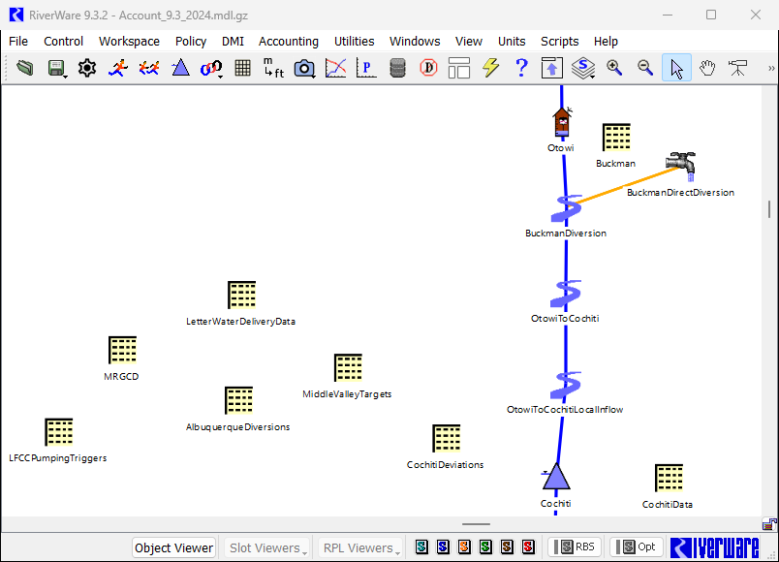

Figure 3‑1. Screen Capture of Portion of URGWOM Workspace – Showing Location of Several Data Objects with Key User Controls

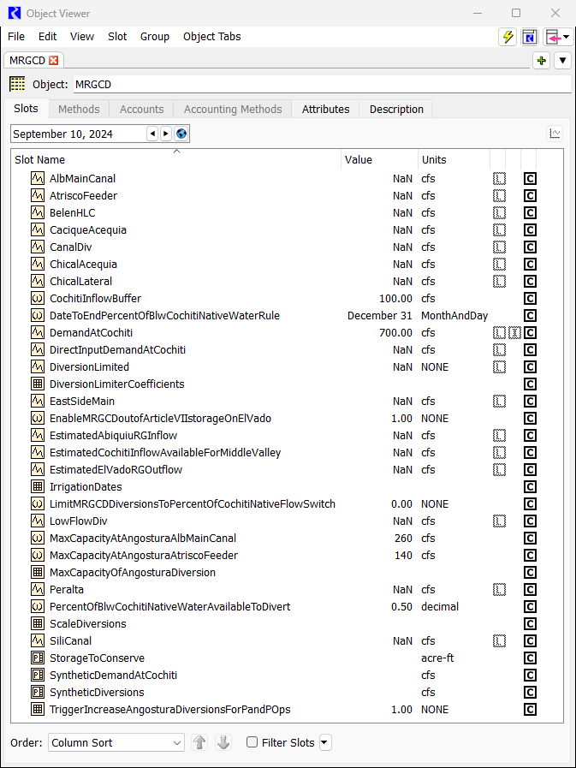

Figure 3‑2: Screen Capture of MRGCD Data Object Slots

Figure 3‑3. Screen Capture of MRGCD.SyntheticDemandAtCochiti Periodic slot

#### Conserving MRGCD Water in Storage for Next Irrigation Season

URGWOM is set up with the capability that water in storage for MRGCD may be conserved for a following year if the available water in storage drops to a user input threshold. The thresholds are input to the StorageToConserve periodic slot in the MRGCD data object (see Figure 3‑4 below). The MRGCD demand at Cochiti is reset to zero if the input threshold storage is not exceeded after the corresponding date to retain that remaining water in storage for the following irrigation season.

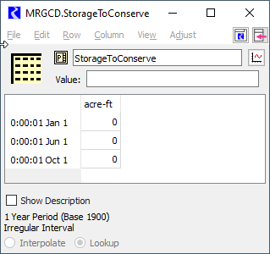

Figure 3‑4: Screen Capture of MRGCD.Storage To Conserve Periodic Slot

A script (MRGCD Operations) has been created to aid the user in accessing and selecting trigger values and/or editing the input of certain slots – see Figure 3‑5, a screen capture of the MRGCD Operations script dashboard and the actions provided in the script.

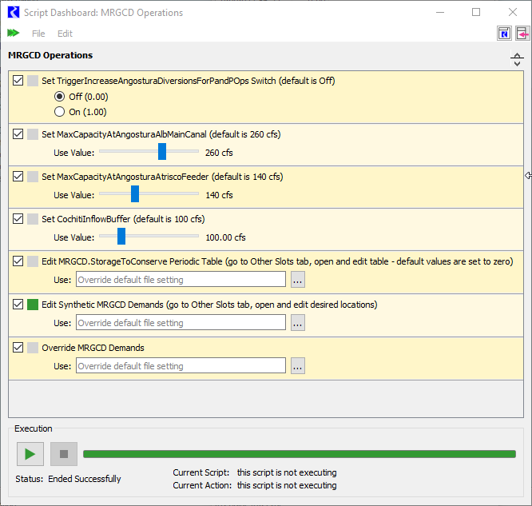

Figure 3‑5: Screen Capture of MRGCD Operations Script Dashboard

#### Diversions for the Six Middle Rio Grande Pueblos

Irrigated acreage for the six Middle Rio Grande pueblos (Cochiti, Santo Domingo, San Felipe, Santa Ana, Sandia, and Isleta) is not represented separately from MRGCD land in URGWOM and diversions to the pueblos are included with MRGCD diversions; however, the storage and release of P&P water to assure the P&P demand is met is tracked separately in URGWOM. The methodology in URGWOM for computing a P&P storage requirement each year and the subsequent releases from P&P storage match the actual implemented approach and are tracked in the PandP account on the El Vado level power reservoir object. Note that a minimum storage requirement can be directly input, if a minimum is already established for an upcoming year, to the InputMinPandP StorageRequirement scalar slot in the PandP data object (Refer to Figure 3‑6 Figure3‑6for a screen capture of a portion of the URGWOM workspace with the PandP data object). The final storage requirement is recorded to the FinalStorageRequirement series slot and will reflect the minimum if the computed value, recorded to the ComputedStorageRequirement series slot, is lower.

Releases are made as needed if the natural flow would not meet the demand for the pueblos as input to the DailyDemandForCallCalc periodic slot in the PandP data object. The SyntheticDemandAtCochiti periodic slot in the MRGCD data object actually represents the full demand at Cochiti for both MRGCD and the pueblos, and releases of native Rio Grande water or MRGCD San Juan-Chama Project water at El Vado Reservoir designated to meet that full demand curve are reduced to account for any releases from P&P storage. All aspects of the approach for P&P storage and releases have undergone a thorough review, and any adjustments to parameters used to compute the storage requirement or releases should only be completed through close coordination with the URGWOM Technical Team and pertinent agency representatives.

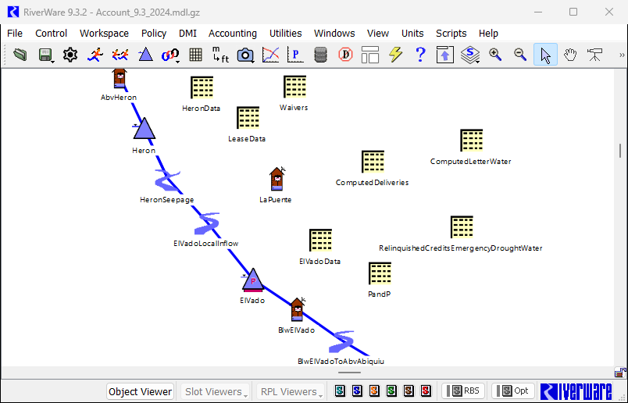

Figure 3‑6: Screen Capture of Portion of URGWOM Workspace – Showing Location of Additional Data Objects with Key User Controls

#### Increased Angostura Diversions with MRGCD Shortage

When MRGCD is in a shortage situation, which is indicated when the MRGCD Demand at Cochiti cannot be met with available water in storage for MRGCD, diversions at Angostura are increased from the regular diversion requested values to the total canal capacity of 400 cfs. These increased diversions assure water is delivered to the pueblos and reflect adjustments in MRGCD operations during shortage situations such that the limited water supply is used most efficiently. The capacity at Angostura is input as two separate values of 260 cfs and 140 cfs to the MaxCapacityAtAngosturaAlbMainCanal and MaxCapacityAtAngosturaAtriscoFeeder scalar slots, respectively, in the MRGCD data object. If this policy is implemented, based on a value of 1.0 in the TriggerIncrease AngosturaDiversionsForPandPOps table slot in the MRGCD data object, this operation will likely result in simulated river drying below the Angostura diversion and will be of particular interest to various stakeholders and should be reviewed carefully against actual expected operations.

### Albuquerque Surface Water Diversions

ABCWUA began surface water diversions in 2009 and the latest potential policy for diversions is set up in URGWOM. An appropriate year must first be set in the AlbuquerqueStartYear table slot in the AlbuquerqueDiversions data object (Figure 3.1) as the year when diversions would begin in a simulation based on the model run period defined in the RiverWare Run Control dialog. URGWOM is set up to model the diversions which typically occur based on a requested delivery of Albuquerque San Juan-Chama Project water from Abiquiu Reservoir with a matching diversion of native Rio Grande water per the 50 percent return flow credit for returns to the river from the wastewater treatment plant. Full Albuquerque diversions may be set to 130 cfs where 65 cfs is provided as San Juan-Chama Project water, as input to the MaxAlbuquerqueSJCDemand periodic slot, and the other 65 cfs is native Rio Grande water that will be returned. Releases of Albuquerque’s San Juan-Chama Project water are set to provide the 65 cfs with loss rates applied. For an AOP model run or planning study, the input demand should be checked against actual expected operations. The loss rate is based on the input San Juan-Chama loss rate from Abiquiu to Cochiti input to the Losses table slot in the SanJuanChama Rules data object and a monthly loss rate from Cochiti to the diversion as input to the CochitiToAlbuquerqueDiversionLosses periodic slot in that same data object (These same loss rates are also set on the appropriate passthrough accounts in the model).

Per the diversion permit, ABCWUA is not permitted to divert native water if low flow thresholds for river flow are not exceeded. Also, if Abiquiu Dam is in flood control operations, San Juan-Chama Project water cannot be delivered to the diversion. Under both circumstances, ABCWUA may shut off the surface water diversions and shift to use all groundwater. URGWOM is currently set up with policy for a preemptive cutoff to diversions that may be implemented before such permit restrictions would result in curtailed diversions or during high flows. The preemptive cutoff represents the assumption that Albuquerque would switch to groundwater during low flows before the actual curtailment threshold are met or when Abiquiu is in flood control operations or also during high flows when it may simply be unsafe or impractical to operate the diversion dam. The high flow thresholds for a preemptive diversion cutoff are input as 1800 cfs out of Abiquiu or 4500 cfs out of Cochiti as input to the ThresholdHighAbiquiu OutflowForAlbPreemptiveCutoff and ThresholdHighFlowCochitiOutflowForAlb PreemptiveCutoff scalar slots in the AlbuquerqueDiversions data object. The threshold low flow for a preemptive cutoff is 200 cfs as input to the ThresholdCentralFlowForAlb PreemptiveCutoff and diversions will not restart until at least two weeks after any preemptive cutoff criterion is not satisfied and the flow at Central is greater than 250 cfs as input to the ThresholdCentralFlowForAlbRestart scalar slot. All the details of the criteria for a preemptive cutoff to ABCWUA diversions were refined as part of modeling work for the PHVA Work Group of the Collaborative Program.

URGWOM is also set up such that cutoffs to ABCWUA surface water diversions could potentially be avoided. If a switch is set to 1.0 in the TriggerUseAllSJCIfNeeded table slot by the model user, all San Juan-Chama Project water will be diverted when low flow thresholds for river flow are not exceeded and the full Albuquerque diversion will be achieved by delivering more San Juan-Chama Project water from Abiquiu Reservoir.

If the switch in the TriggerModelElephantButteExchange table slot is set to 1.0, full diversions will be modeled when Abiquiu is in flood control operations and San Juan-Chama Project water cannot be delivered. A debt is tracked with the Albuquerque PaybackToRioGrandeForDiversionDuringFloodOps exchange for the debt to the native Rio Grande water supply. An Albuquerque payback is then modeled as a follow-up transfer from the Albuquerque account on the Elephant Butte reservoir object to the Rio Grande account. The transfer occurs on the date input to the DateForTransferTo RioGrandeAtElephantButteForPayback column in the DeliverySettings table slot in the ComputedDeliveries data object Figure 3‑7:

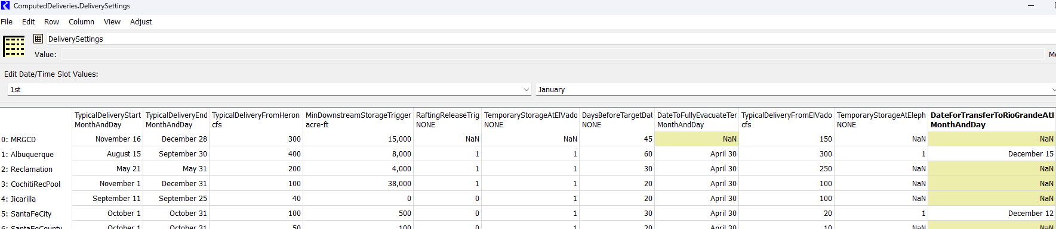

Figure 3‑7: Screen capture of ComputedDeliveries.DeliverySettings table in URGWOM

### Letter Water Deliveries

Contractors for San Juan-Chama Project water may cause depletions in the basin and then use allocated San Juan-Chama Project water to payback the river. Actual paybacks are determined by the Office of the State Engineer using groundwater models or other tools, and the deliveries are requested as letters from the State to Reclamation, hence the name “letter water deliveries.” The timing for paybacks would theoretically match the timing for the depletion to the river. Paybacks to the Compact are usually scheduled to occur in the non-irrigation season to assure the water is not diverted and is efficiently conveyed to Elephant Butte Reservoir.

Within URGWOM, payback volumes are input for each contractor for San Juan-Chama Project water to table slots (in the TotalPaybackVolume column) in the LetterWater DeliveryData data object (Refer to Figure 3.1 for a screen capture of a portion of the URGWOM workspace with the LetterWaterDeliveryData data object). Volumes are input for each year of simulation, and a portion of the payback to pay back the Compact versus MRGCD in input (as a percentage in the Ratio ToCompact column). The payback to MRGCD may be modeled as a transfer to the MRGCD account at El Vado Reservoir (if the switch is set in column 3) or a release from the source contractor storage account at Abiquiu toward meeting the MRGCD demand as needed. Refer to Figure 3‑8 for a screen capture of a sample input table for Albuquerque.

Figure 3‑8: Screen capture of LetterWaterDeliveryData.Albuquerque table in URGWOM

The Exchanges Manager in RiverWare is used to establish the debt for contractors to deliver water and track the payback. If a contractor does not have water in storage at the time of a delivery request, the debt is maintained until the contractor has the water to make the payback. Three separate exchanges are included for each contractor to track the potential paybacks to MRGCD as transfers to the MRGCD account at El Vado Reservoir, to MRGCD as releases from Abiquiu Reservoir toward meeting the MRGCD demand in the Middle Valley, and to the Compact. A sample Exchange is presented in Figure 3‑9 that shows the tracked debt to be paid back and the deliveries to pay back the debt. The Exchanges are accessed from the Exchanges Manager included in the Accounting menu in RiverWare. Unit hydrographs are included for each contractor in the UnitDelivery ScheduleForPaybackToCompact periodic slot in the LetterWaterDeliveryData data object for setting releases to pay back the Compact. If paybacks to MRGCD are to occur as a transfer to the MRGCD account at El Vado, indicated by the switch set in the table slot for each contractor in the LetterWaterDeliveryData data object, the transfer will occur on the date input for each year in that same table slot if the supply is available from the source account.

A list of the annual payback volumes from the most-recent URGWOM model is presented in Table 3‑1 for all contractors, but the volumes should be checked against any available projected payback information from the Office of the State Engineer and the model setup should be coordinated with the URGWOM Technical Team. The volumes in Table 3‑1 would be input for each year (i.e., each row) in the TotalPaybackVolume column of the corresponding table slots in the LetterWaterDeliveryData data object. Annual volumes for Albuquerque paybacks are more significant due to the impact of past pumping and will vary from year to year depending on the overall status of that payback. Payback volumes for Albuquerque and Santa Fe City have decreased over the last few decades due to reduced groundwater pumping with the startup of their surface water diversions. Note that since letter water delivery volumes are relatively small for contractors other than Albuquerque, which has a larger pending payback for past pumping, the letter water delivery volumes have been set to zero for some past AOP model runs.

Table 3‑1: Potential Assumed Annual Letter Water Delivery Volumes for Contractors for SJC Water

|  |  |
| --- | --- |
| Contractor | Annual Delivery (acre-ft) |
| Aamodt Settlement | 0 |
| Albuquerque | 12000 |
| Belen | 62 |
| Bernalillo | 100 |
| El Prado | 0 |
| Espanola | 113 |
| Jicarilla | 0 |
| Los Alamos | 0 |
| Los Lunas | 160 |
| OHKAY Owingeh | 0 |
| PVID | 0 |
| Red River | 0 |
| Santa Fe City | 112 |
| Taos Pueblo | 0 |
| Taos Ski Valley | 8 |
| Town of Taos | 0 |
| Town of Taos Settlement | 0 |

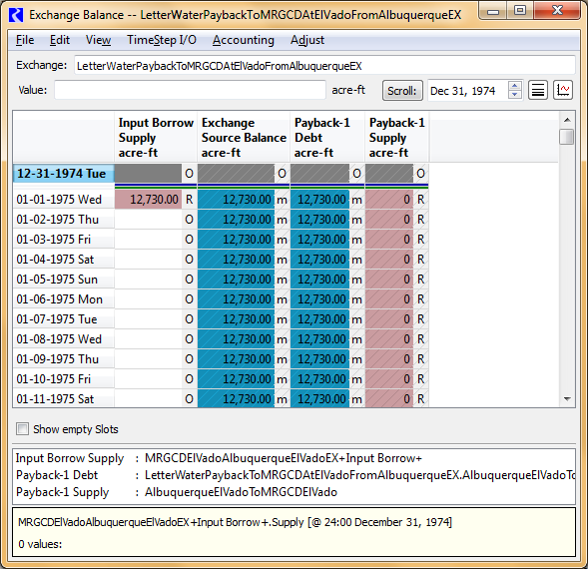

Figure 3‑9: Sample Exchange in URGWOM Used to Track Contractor Letter Water Debts and Paybacks

### Target Flows for ESA Operations

The current version of URGWOM is set up to model releases of supplemental water for Middle Rio Grande flow targets that reflect the flow requirements under the 2003 BO. Supplemental water may consist of leased San Juan-Chama Project water or Emergency Drought Water stored at El Vado Reservoir that is specifically designated for ESA considerations. More details on these two sources of supplemental water are presented in sections 3.3.1 and 3.3.2. Daily needed releases from Abiquiu Dam to meet targets at Central, Isleta, San Acacia, and San Marcial are computed in the model using RiverWare hypothetical simulations, or separate side simulations in RiverWare to iterate and solve for the flow needed upstream at Cochiti and then Abiquiu to meet the targets. The locations of these targets in the model match the following slots: Central.Gage Outflow, IsletaDiversionDam.Outflow, SanAcaciaFloodway.Gage Outflow, and SanMarcial Floodway.Gage Outflow. Targets are defined in the MinTargetFlows periodic slot in the MiddleValleyTargets data object (Figure 3‑10) where targets are set as a function of defined hydrologic conditions (Discussed in section 3.1.4.1). A step down in targets is included in the table following the targets set up for the winter continuous flow requirement. That step down is needed to assure there is management for the recession in flows after the continuous flow requirement ends. Step downs in targets to manage the recession after the runoff – separate and key if the runoff ends after the continuous flow requirement – or to control the rate of river drying after any river rewetting may be triggered as part of discretionary operations as discussed in section 3.1.4.3.

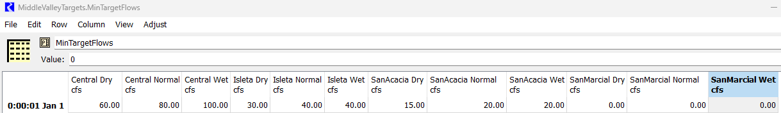

Figure 3‑10: Screen capture of Middle Valley ESA targets in URGWOM

#### Hydrology Year Type

The year classification for setting targets in the model is set based on a March through July forecasted flow volume at Otowi calculated with reference to input inflows. The year will be classified as dry, average, or wet based on the forecasted flow volume relative to defined thresholds set as a percentage of the historical average flow volume. These percentages are input to the ForecastFactorsForHydYearType table slot in the MiddleValleyTargets data object, and the average March through July Otowi flow volume is input to the AverageOtowiForecast scalar slot in the PandP data object. The determined year classification on May 1st is maintained for the remainder of a calendar year. A year is classified as dry if stipulations of Article VII of the Compact are in effect (refer to section 3.2.2.3 for more details on Article VII of the Compact), but since the year classification is set for the remainder of the year on May 1st, the year classification will not change if the Article VII status changes after May 1st. The year classification can also be set by the model user to utilize dry, average, or wet targets with direct input values of 1, 2, or 3 respectively.

#### Adjustment Factor for Targets

An adjustment factor can be included that will increase targets by a percentage (i.e., a target of 100 cfs will increase to 125 cfs with a 25% adjustment factor). A 25% adjustment factor is currently applied in URGWOM to targets because the model can set releases from Abiquiu to hit targets in the Middle Rio Grande with much better precision than can be done in actual operations. Uncertainty about conveyance losses, MRGCD returns, local inflows, etc. combined with the travel time from Abiquiu to target locations and other physical operational constraints prevent actual releases from being adjusted with such precision, so an adjustment factor is applied to targets in the model such that modeled supplemental water releases more accurately reflect actual release volumes. Values for the adjustment factor are input to the MinTargetFlowsSafetyFactor periodic slot in the MiddleValleyTargets data object. The value of 25% included in the current model was identified as an appropriate adjustment factor based on a comparison of historical supplemental water use from 2003 through 2006 and URGWOM simulation results for supplemental water needed from a past test run using the historical 2003 through 2006 hydrology for inputs.

#### Discretionary Operations under 2003 BO

URGWOM is set up to simulate discretionary operations, that may be conducted under the 2003 BO, which entail using supplemental water to manage the recession after the runoff and/or control the rate of drying after river rewetting. Modeled operations may entail implementing a 30-day step down in targets at the end of the runoff and/or 7-day step downs in targets thereafter following each river rewetting event. Both of these aspects of potential discretionary operations can be turned off by setting the corresponding value in the MiddleValleyTargets.TriggerImplementStepDownInTargets table slot to zero. The operation will be included as modeled policy if the input value in this scalar slot is 1. Recent applications have included the step down in targets to manage the recession, but it is recommended to leave the separate step downs to control the rate of river drying turned off and only add this operation if relevant for the modeling study identified through coordination with Reclamation and the URGWOM Technical Team.

#### Shorted Diversions to Prevent Diversion of Supplemental Water

If MRGCD is in a shortage situation and does not have the required water supply to meet their full demand in the Middle Rio Grande, it is possible that full requested diversions would not be met. Requested diversions at the MRGCD diversions may be reset lower if MRGCD is in such a shortage situation to prevent released supplemental water from being diverted that is specifically designated for meeting flow requirements under the 2003 BO. This adjustment is implemented in an URGWOM simulation by completing additional RiverWare hypothetical simulations to identify what the diversions would be without supplemental water, and requested diversions to the main canals at the MRGCD diversions are reset from full requested diversions to the determined shorted diversion. **Requested Diversions will only be reset lower if there are downstream targets.** If there are no downstream targets, it is assumed that any supplemental water still in the river is available for diversion. For example, if supplemental water is released to meet a target flow at Central, diversions might be shorted at Cochiti or Angostura if MRGCD would not have received their full requested diversion at those locations without supplemental water, but if there are no targets below Central, remaining supplemental water in the river would then be diverted at the Isleta diversion during such a shortage situation.

### Buckman Direct Diversions

The Buckman Direct Diversion is modeled in URGWOM with water for Santa Fe City and Santa Fe County diverted just below the Otowi stream gage object. Diversions are modeled based on an average rate for the two separate contractors for San Juan-Chama Project water to use their allocations, and an average rate for diversion of native Rio Grande water are also included that reflect water rights for Santa Fe City and Santa Fe County that may are in place for diverting native water. Portions of Rio Grande water diverted for the mixing operation at the diversion are also included for each, and the return flow fraction for the diversion is computed for the immediate return of this portion of the diversion.

The average daily diversion amounts of San Juan-Chama Project water, native water based on available water rights, and native water for mixing for both Santa Fe City and Santa Fe County are input to the DiversionPortions table slot in the Buckman data object (Refer to Figure 3‑11 for a screen capture of a portion of the URGWOM workspace with the Buckman data object).

Figure 3‑11: Screen capture of Buckman.DiversionPortions table in URGWOM

A startup date for the diversion is input to the BuckmanStartDate scalar slot, currently set to December 31, 2009. A switch is also included in the Buckman.TriggerModelElephantButteExchangeSantaFeCity table slot to allow for Santa Fe City diversions to continue with all native water when San Juan-Chama Project cannot be delivered because Abiquiu Dam is in flood control operations. Similar to the setup for ABCWUA, under such situations, a debt is tracked with an Exchange and the debt is paid back with a transfer of Santa Fe City water to the Rio Grande account at Elephant Butte. Criteria for the potential curtailment or cutoff of diversions of native Rio Grande water are represented per actual policy with reference to low flow thresholds in river flow.

## Reservoir Storage and Releases

Demands in the Middle Valley are met with specific sources of water. The MRGCD Demand at Cochiti is first met with natural flows plus any releases of P&P water. If contractors have pending letter water deliveries to be made as releases from Abiquiu Reservoir toward meeting the demand, those letter water deliveries are made. Any Emergency Drought Water available for MRGCD will then be released if needed to meet the MRGCD demand and then available native Rio Grande water in storage at El Vado is released. If no native Rio Grande water is available in storage, MRGCD San Juan-Chama Project water is released as the last available option for augmenting flows to meet the full MRGCD demand at Cochiti. If no San Juan-Chama Project water allocated to MRGCD is available, MRGCD is in a shortage situation and requested diversions likely will not be fully met after the runoff. Development and revisions to the URGWOM rules would be required to change the priorities at which available water in storage is used to meet the MRGCD Demand.

Albuquerque’s demand for the surface water diversion is met by releasing Albuquerque’s available San Juan-Chama Project water from storage at Abiquiu Reservoir, and Santa Fe City and Santa Fe County water is released from Abiquiu for the Buckman Direct Diversion. Needs for meeting Middle Valley targets are first met with available Emergency Drought Water from El Vado Reservoir and supplemental water from the Reclamation account at Abiquiu Reservoir is used next as available from leases for contractor’s San Juan-Chama Project water.

More details on factors affecting individual deliveries and total reservoir releases are discussed below with focus on San Juan-Chama Project water related topics versus operations for native Rio Grande flows. While the rules are configured to compute individual deliveries, and those values are recorded to separate series slots in the ComputedDeliveries data object or the ComputedLetterWater data object. The individual deliveries are summed to determine a total reservoir release. The determined individual deliveries can also be manually input by the model user if a particular adjustment to operations is needed. The rules will identify that a value has been directly input for a delivery for a given timestep and then not determine a value. This capability in URGWOM is particularly valuable for AOP modeling where a known operation for a near term period needs to be directly input. The total reservoir outflow can also be directly input to the TotalOutflowDirectlyInputToOverrideRules series slot in the companion data object for a reservoir (e.g. ElVadoData).

### San Juan-Chama Project Water

Diversions from the San Juan basin through San Juan-Chama Project facilities to Heron Reservoir are computed with rules with reference to the input flows in the San Juan tributaries and with consideration for diversion restrictions including an annual diversion limit, a ten-year diversion limit, and the available space at Heron Reservoir. Note that if Heron Reservoir is full during a simulation, diversions may be curtailed due to the lack of space and this would likely be of particular interest to stakeholders. It is unlikely that the annual diversion limit or ten-year diversion limit would affect diversions.

San Juan-Chama Project water at Heron is first tracked in the model with the FederalSanJuan storage account on the Heron storage reservoir object. In rulebased simulations, water is allocated to contractors for San Juan-Chama Project water on January 1st of each calendar year based on the annual allocations input to the SanJuanContractorAllocations table slot (Figure 3‑6) on the HeronData data object. Additional allocations up to the contracted total allocation can be made in the same manner each month if full allocations could not be made in January, until their allocation is fulfilled. The months to perform any potential additional allocations is input (as a decimal up to a value of 1) to the SanJuanContractorAllocationMonthlyRatios table slot on the HeronData data object (Refer to Figure 3‑1 for a screen capture of a portion of the URGWOM workspace with the HeronData data object). The day of the month to calculate the additional allocation and the day of the month to allocate the additional allocation is set in the DayOfMonthForAdditionalSJCAllocations periodic slot. There is an option to short the CochitiRecPool the same as the other contractors using the HeronData.CochitiRecPoolCanBeShorted scalar slot (by setting a value of 1), otherwise the CochitiRecPool will get its full allocation on January 1st. There is also a periodic slot the user can input estimated monthly evaporation volumes (HeronData.Estimated Evaporation for Allocation periodic slot) to attempt to not allow the Federal Pool to compute negative storages later in the year (when the HeronData.Use Estimated Evap for Allocation scalar slot is set to 1).

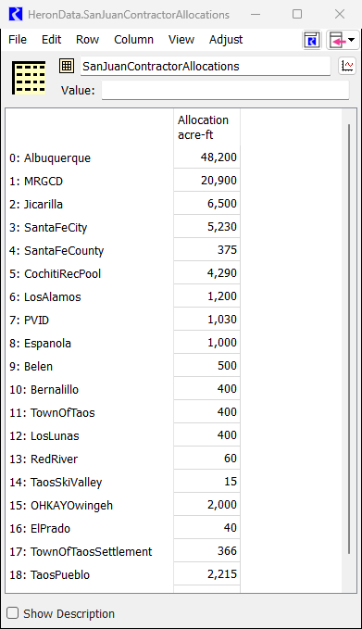

Figure 3‑12: HeronData.SanJuanContractorAllocations Table Slot

#### Allocated Storage Space for Contractor San Juan-Chama Water

Contractors may have allocated storage space at Abiquiu Reservoir for San Juan-Chama Project water as input to the MaxAccountStorage periodic slots in the AbiquiuData data objects (Figure 3‑13). The setup allows for varying amounts of space to be defined for each future year of a planning simulation. Note that actual allocated storage space is adjusted each year based on estimated sedimentation at Abiquiu Reservoir, so values in URGWOM may need to be updated each year for new AOP model runs and values for future years should be estimated for long-term planning runs and set accordingly in the MaxAccountStorage period slot. Storage is allowed at Abiquiu Reservoir up to a pool elevation of 6220 ft (Easement approvals from land owners are needed for storage above 6220 ft). In 2023, Public Law 116-260 authorized an increase in conservation storage elevation from 6220 feet to 6230 feet, allowing for storage of up to 229,199 acre-feet. The City of Albuquerque can now store Rio Grande water up to this elevation, although this is not yet modeled in URGWOM. The summation of the allocated storage space should match the storage at 6220 ft with consideration for sedimentation recorded to the Accumulated Perm Sediment column of the Abiquiu.Est Sed Deposition aggregate series slot. It is important to include a 2000 acre-ft operating pool for MRGCD water potentially being delivered from El Vado Reservoir to meet their full demand at Cochiti Dam.

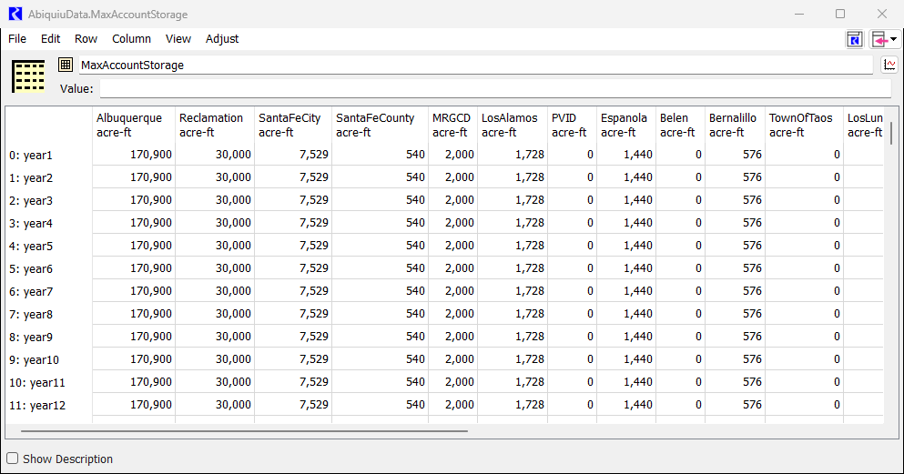

Figure 3‑13: AbiquiuData.MaxAccountStorage Periodic Slot

MRGCD has all available allocated storage space at El Vado Reservoir, but it could be assumed that MRGCD would allow other contractors to store water at El Vado if space is available that MRGCD cannot use. URGWOM is set up to potentially allow for contractors to temporarily store San Juan-Chama water at El Vado Reservoir if a switch has been set by the model user. The available space for the contractor is then computed based on an estimated amount that the contractor could evacuate before the next runoff. The switch for each contractor is included in the TemporaryStorageAtElVadoAllowed (1=Yes,0=No) column of the DeliverySettings table slot in the ComputedDeliveries data object (see Figure 3‑7 below). For recent planning studies, it has been assumed that contractors other than MRGCD would not temporarily store water at El Vado Reservoir.

#### Waivers for Retaining Water at Heron Reservoir for an Extended Period

URGWOM is set up to allow contractors for San Juan-Chama Project water to retain allocated water, as discussed in section 3.2.1, in storage at Heron Reservoir into the year after the year the water was allocated if waivers are implemented for the contractor. The water then must be evacuated by the waiver date in that following year. The current authorized waiver date of September 30th is input to the WaiverDate table slot in the Waivers data object in the current model. Waivers are allowed for a contractor if the switch has been set to 1.0 for the contractor for the current simulation year in the WaiverGranted table slot. The waiver balances, as a portion of the total account storage at Heron Reservoir for each contractor, are tracked in separate series slots in the Waivers data object (Refer to Figure 3.3 for a screen capture of a portion of the URGWOM workspace with the Waivers data object).

Coded policy entails releasing waiver water as possible during the waiver year by the waiver date. Releases begin a set number of days before the waiver date as input to the DaysBeforeTargetDateToStartMovingWater column in the DeliverySettings table slot in the Computed Deliveries data object. The release rate is set to the higher of a computed rate to evacuate all the waiver water over that period or the typical release rate for the contractor as input to the TypicalDeliveryFromHeron column of the same table slot with consideration for available downstream storage space. Note that if contractor waiver water is to be leased by Reclamation, any pending lease is considered when evaluating a potential amount of remaining contractor waiver water to be evacuated from Heron Reservoir.

#### Deliveries to Allocated Storage Space

Allocated San Juan-Chama Project water for contractors, as discussed in section 3.2.1, is periodically delivered to allocated storage space as discussed in section 3.2.1.1. The movement of contractor San Juan-Chama Project water at Heron Reservoir to allocated storage space at Abiquiu Reservoir and potential space at El Vado Reservoir is controlled with parameters in the DeliverySettings table slot in the ComputedDeliveries data object (Figure 3‑7). Contractor water may be moved to Abiquiu Reservoir on a given day based on a few different considerations. First, water will be moved immediately, as available, to maintain an input minimum downstream storage for the contractor as input to the MinDownstreamStorageTriggerImmediateDelivery column in the DeliverySettings table slot. Also, contractor water will also be moved to available downstream storage space if it is determined that water should be moved on that date to avoid being lost at the end of the calendar year, and if waivers are in effect for the contractor, water will be moved by the waiver date in the year after the year the water was allocated. If those conditions are not in effect, contractor water may be moved if needed to augment flows for rating below El Vado Dam and the switch is set for the contractor in the RaftingReleaseTrigger

(1=Raft,0=NoRaft) column of the DeliverySettings table slot. Ideally, water is moved within a single input period at a rate to evacuate all the water over that period or an input typical release rate if that input release rate is greater. The input typical delivery period is defined by the dates in the first two columns of the DeliverySettings table slot.

Space at El Vado Reservoir is first used for MRGCD water, but if additional space is available, contractor water may be moved to El Vado Reservoir if space is not available at Abiquiu for the contractor and the switch is set for the contractor in the TemporaryStorageAtElVadoAllowed(1=Yes,0=No) column in the DeliverySettings table slot. Water is then moved to El Vado Reservoir only if necessary to prevent the allocated water at Heron Reservoir from being lost. The amount of space at El Vado Reservoir then allocated for a contractor is based on an estimate of the amount of water that the specific contractor can move out of El Vado Reservoir before the next runoff, or the date input to the DateToFullyEvacuateTemporaryStorageAtElVado column of the DeliverySettings table slot. For example, the space available for Albuquerque water at El Vado Reservoir would be based on an estimate of the space that would free up at Abiquiu Reservoir by the input date in the next year with consideration for pending Albuquerque deliveries by then for the surface water diversion and as letter water deliveries.

##### Cochiti Rec Pool

Releases of San Juan-Chama Project water for the Cochiti Recreation Pool are set in a similar manner to the releases of contractor water to allocated storage space with reference to settings in the CochitiRecPool row in the DeliverySettings table slot in the ComputedDeliveries data object. Cochiti Rec Pool water can be used to provide rafting flows below El Vado Dam. Note that Cochiti Rec Pool water is not tracked as waiver water and unused Rec Pool water reverts back to the FederalSanJuan account at the end of each year. The space at Cochiti is defined by two potential options. If the value of the SwitchForCochitiRecPoolContent in the CochitiData data object is set to zero (Figure 3‑14), releases are made to fill the allocated rec pool space defined by the storage value in the Permanent Sediment Content table slot in the Cochiti storage reservoir object. The current (2024) input value of 44,129 acre-ft provides the Cochiti rec pool surface area of 1200 acres based on the input elevation-area-capacity tables; however, with modeled sediment accumulation at Cochiti Lake, the reservoir storage for maintaining the rec pool gradually increases during a simulation under that approach. Alternatively, if the value of the SwitchForCochitiRecPoolContent slot is set to 1.0, the target content of the Cochiti Rec Pool will be looked up each day during a simulation as the amount needed to maintain a reservoir surface area of 1200 acres and will decrease during a simulation due to modeled sedimentation.

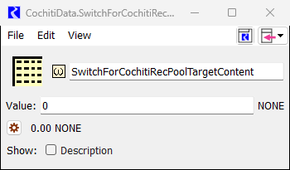

Figure 3‑14: SwitchForCochitiRecPoolContent Slot

#### Scheduled Paybacks for Past Albuquerque Loan to MRGCD

URGWOM is set up such that model users can input parameters to model an MRGCD payback to Albuquerque for a past loan. This option allows for the payback to be modeled for a loan that occurred prior to an analysis period (This capability has been needed for recent AOP model runs). Special accounting supplies and passthrough accounts are included in URGWOM for this operation to deliver water from the MRGCD account at El Vado to the Albuquerque account at Abiquiu. The volume of the payback for each year of simulation is input to the PaybackScheduleForPastAlbuquerqueLoan ToMRGCD table slot in the ComputedDeliveries data object (Figure 3‑15). A period for the payback is defined by dates in the same table slot. The payback rate is set to the higher of either the release rate to deliver the volume over the defined payback period or the value in the MinimumDeliveryRate column.

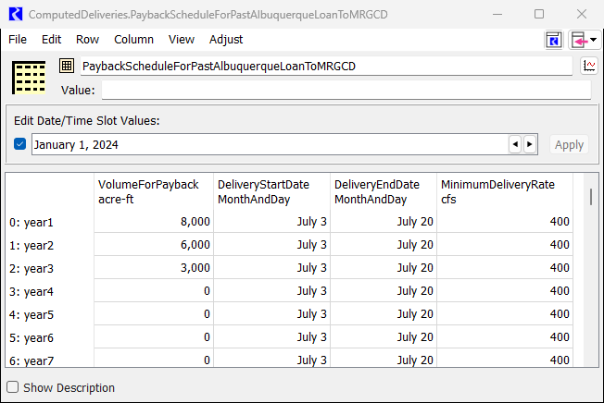

Figure 3‑15: PaybackScheduleForPastAlbuquerqueLoanToMRGCD Slot

### Native Rio Grande Water

Native Rio Grande water is effectively bypassed at Heron Reservoir, but there is a restriction that the Heron pool elevation cannot change by more than one foot per day (Input to the HeronData.maxDeltaPoolElev table slot). Rio Grande water may be stored at El Vado as discussed further below, and native Rio Grande water may be stored at Abiquiu Reservoir and Cochiti Lake for flood control operations. Policy for making stepped releases at Abiquiu and Cochiti Dams is included in the URGWOM ruleset. Inflows are bypassed at Jemez Dam unless storage is needed to maintain a downstream flow below channel capacity restrictions through coordinated operations with Cochiti Dam.

#### Channel Capacities

Water may be stored at Abiquiu Reservoir to assure the downstream channel capacities are not exceeded as input to the AbiquiuData.ChannelCapacities table slot. The capacity immediately below Abiquiu Dam is input as 1800 cfs, and the capacities at Chamita and Otowi are 3000 and 10,000 cfs, respectively. Channel capacities below Cochiti Dam are input to the CentralChannelCapacity and SanMarcialChannelCapacity periodic slots in the CochitiData data object. In the current model, the Central channel capacity is set to 7000 cfs and the San Marcial channel capacity is input as 6000 cfs. Different channel capacities for different periods within a calendar year could be established. A series slot called ChannelCapacityOpsFlag is set up in the CochitiData data object to indicate which channel capacity controlled the outflow with a value of 1 indicating the Central channel capacity controlled and a value of 2 indicating the San Marcial channel capacity controlled (a NaN value in this slot for a timestep indicates that channel capacities did not control the release on that day). Channel capacities below Elephant Butte and Caballo Dams are input to the ChannelCapacities table slot in the ElephantButteData and CaballoData data objects. The channel capacity below Elephant Butte Dam is input as 5000 cfs, and the channel capacity below Caballo Dam is set to 3500 cfs with a capacity of 11,000 cfs at El Paso.

#### Carryover Storage

Water stored at Abiquiu and Cochiti Reservoirs during flood control operations will be subsequently released as possible, but any water still in storage after July 1st and after the flow at Otowi (exclusive of flood storage evacuated from upstream reservoirs) drops below 1500 cfs, as input to the MinLockinFlow table slot in the FloodCarryOverData data object, will be retained in storage if 212,000 acre-ft of space is available in Cochiti Lake. Carryover storage will be released starting on a date as input to the column corresponding with the reservoir in the DateToStartConstantCarryoverRelease table slot in the FloodCarryOverData data object and released at a determined constant rate such that the water is evacuated by March 31st. Resulting storage of Rio Grande water at Abiquiu Reservoir and/or Cochiti Lake from a simulation for an upcoming year, including any potential carryover storage, should be checked as this operation would be of particular interest to stakeholders.

#### Article VII of the Compact

Inflows of native Rio Grande water at El Vado Reservoir will be stored if not needed to meet downstream demands and if the stipulations of Article VII of the Compact are not in effect. Article VII of the Compact (States of New Mexico, Colorado, and Texas, 1938) stipulates that water may not be stored in reservoirs constructed after 1929 if there is less than 400,000 acre-ft of usable storage, where usable storage is calculated as the total storage at Caballo Reservoir plus the storage at Elephant Butte Reservoir, not including any San Juan-Chama Project water or the end of previous year Compact credit water for New Mexico and Colorado. Usable storage is computed in the model and recorded to the UsableStorage series slot in the RioGrandeCompact data object, and the resulting Article VII status is recorded to the ArticleVIISwitch series slot in that data object where a value of 1 indicates that Article VII is in effect and a value of 0 indicates that the provision is not in effect. Note that the usable storage adjusts immediately for any accounting transfer from the New Mexico Compact credit account to the Rio Grande account as a result of relinquished credits as discussed further in section 3.3.2.

#### Storage at El Vado Reservoir

If the stipulations of Article VII of the Compact are in effect, inflows of native Rio Grande water at El Vado Reservoir will be bypassed after water has been stored to meet the final P&P storage requirement as discussed in section 3.1.1.2 and water has been stored to fill any allocated space for Emergency Drought water as a result of relinquished Compact credits (Refer to section 3.3.2). Releases may include the release of P&P water as needed and releases of any available native Rio Grande water already in storage to meet the MRGCD demand as needed.

If Article VII is not in effect, native Rio Grande water will be stored as not needed to meet the MRGCD demand to ultimately completely fill reservoir as possible. The approach for filling the reservoir entails storing all inflows up to a determined elevation that will maintain some buffer space prior to the peak inflow. The reservoir is then completely filled on the recession of the runoff. The amount of buffer space to maintain prior to the peak is computed as a function of the forecast with a cubic regression equation calibrated using data for numerous historical years. The reservoir will then be completely filled after an input number of days after the peak and after the recession has dropped below an input threshold flow. Another criterion is also incorporated where the reservoir is not completely filled until the inflow volume during the runoff has already exceeded an input fraction of the forecasted runoff volume. The entire approach was refined such that the reservoir is not filled too soon to risk the downstream channel capacity being exceeded but also such that the reservoir can still be completely filled to assure the water supply is used efficiently.

The approach in URGWOM for filling El Vado Reservoir when Article VII is not in effect serves as a potential guide for operators but modeled operations should be reviewed against all standard operating procedures before any model results are actually used to influence policy decisions. A date and magnitude of the peak inflow for each simulation year are recorded to the EstimatedPeakInflow and EstimatedPeakInflowDate slots in the ElVadoData data object (Figure 3.3). The values for each year are recorded at the December 31st timestep in the series slots. Refined parameters for controlling how the reservoir is filled as included in the FillingParameters table slot in the ElVadoData data object should only be adjusted through close coordination with Reclamation and the URGWOM Technical Team.

##### Article VIII of the Compact

URGWOM is set up to model El Vado Dam releases that would be made based on a call by Texas per Article VIII of the Compact which essentially states that Texas may call for a release, starting in January, of water in storage from post-Compact reservoirs to the amount of an accrued Compact debt to bring the usable storage up to 600,000 acre-ft. A switch to identify whether this policy should be modeled is included as the Trigger ImplementArticleVIIIOps scalar slot in the RioGrandeCompact data object. This policy will be modeled if a value of 1 is entered in this scalar slot but will not be included if the value is set to 0. This aspect of policy would likely be turned off for an AOP model run but is included in the ruleset for long-term studies completed or for specific evaluations of the potential impact of the provision.

The coded policy entails referencing a threshold debt for when a call would actually be made as input to the ThresholdCompactCreditToStartArticleVIIIOps scalar slot in the RioGrandeCompact data object which is set to -20,000 acre-ft in the current model based on the assumption that Texas would not actually make a call until the debt accrued exceeds 20,000 acre-ft. Releases are made in the model by establishing a new minimum release of Rio Grande water for an Article VIII release season as set in the ArticleVIII ReleaseSeason table slot in the RioGrandeCompact data object. Releases are set to a computed average rate to release a volume equal to the Compact debt over the Article VIII release season, but no release will be made if there is no Rio Grande water in storage.

#### Releases from Elephant Butte and Caballo Dams

The model user has the choice of using either Pattern-based rules to set reservoir releases from Caballo, or Demand-based rules. This selection is found in the Configuration.Use Demand Based or Pattern Based Diversions scalar slot. Both options require the Lower Rio Grande portion of URGWOM to be enabled.

If the Lower Rio Grande portion of URGWOM is disabled, it is recommended that the Caballo release for the entire run period is input on the CaballoData.TotalOutflowDirectlyInputToOverrideRules series slot. Alternatively, Reclamation is in the process of developing an empirically based Caballo release rule that can work when the Lower Rio Grande is disabled, based on the year’s initial Project storage and year-to-date inflow. This empirically based Caballo release rule is not yet in URGWOM.

Releases from Caballo are adjusted for channel capacities and flood control.

Elephant Butte releases are based on a storage target at Caballo, found in the CaballoData.Storage Target periodic slot:

Figure 3‑16: Screen capture of the Caballo Storage Target in URGWOM

Elephant Butte releases are adjusted for power generation, to prevent damage to downstream archeological sites, and for flood control. More information can be found in URGWOM Documentation Volume 2a: Rules.

## Potential Water Agreements

Details about water agreements that should be represented in an URGWOM simulation need to be identified before setting up a model run. URGWOM is set up to model some agreements that have been implemented historically including the following: Reclamation leases of San Juan-Chama Project water from contractors, relinquished Compact credits and storage of Emergency Drought water, Cochiti deviations to provide recruitment or overbank flows, and pumping from the Low Flow Conveyance Channel. URGWOM is also set up to model reregulation storage at Abiquiu Reservoir, Cochiti Lake, and Jemez Reservoir; however, such full time conservation storage has not actually been approved and implemented but can be studied with URGWOM.

### Reclamation Leases

Supplemental water is used to meet target flows in the Middle Valley as discussed in section 3.1.4. There are two sources for supplemental water: water may be leased by Reclamation from contractors for San Juan-Chama Project water or native Rio Grande water may be stored as Emergency Drought water at El Vado Reservoir (Refer to section 3.3.2 for more details on Emergency Drought Water). Leases of San Juan-Chama Project water by Reclamation from contractors are modeled as transfers from the source account storage to Reclamation’s account where the transfers can occur at Heron, El Vado, and/or Abiquiu Reservoir. Details for the magnitude and timing for Reclamation leases for an upcoming year must be identified for a model run and set up by the model user.

These transfers are made based on values set to separate table slots in the LeaseData data object for each contractor for San Juan-Chama Project water (Refer to Figure 3.3 for a screen capture of a portion of the URGWOM workspace with the LeaseData data object). A lease amount is input for each year of simulation along with the date for the transfer to occur. Transfer information is set for each reservoir (Heron, El Vado, and Abiquiu). For Heron, a switch is also included to indicate whether waiver water or current year allocation water is being leased. Refer to Figure 3‑17 for a sample table slot with lease information. If the source storage account does not have the available water needed during the simulation for an input transfer amount, the transfer is not made.

Figure 3‑17: Sample Table Slot with Values for Reclamation Leases

More information about Leases is often hand-entered using Notes, which can be accessed from the Workspace/Utilities/Note Manager:

Figure 3‑18: Screen Capture of Note Manager

#### Threshold YTD Otowi Flow Volume for Conserving Lease Water

A test policy for conserving leased San Juan-Chama Project water during wet periods is currently established in URGWOM where lease water will not be used for targets after a threshold year-to-date Otowi flow volume has been reached. This threshold volume is input to the ThresholdOtowiVolumeHoldLeaseWater scalar slot (Figure 3‑19) in the MiddleValleyTargets data object. A value of 1,000,000 acre-ft has been analyzed previously as part of work for the PHVA Work Group of the Collaborative Program, but this policy should not be included in URGWOM runs unless such a policy is being studied or is actually implemented. In URGWOM, this policy is effectively turned off by setting the value to 999,999,999 acre-ft, which should never be met.

This policy as coded only applies to leased water. Available Emergency Drought water would still be used to meet targets regardless of the year-to-date Otowi flow volume. Any actual alternative policies for conserving leased water could be implemented into the model but any new defined policy would need to be implemented by the URGWOM Technical Team.

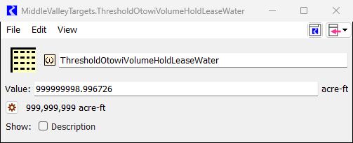

Figure 3‑19: ThresholdOtowiVolumeHoldLeaseWater Scalar Slot

### Relinquished Compact Credits and Emergency Drought Water

URGWOM is set up to potentially model relinquished Compact credits. Subsequent storage of Emergency Drought water at El Vado Reservoir is then modeled when stipulations of Article VII of the Compact are in effect (Refer to section 3.2.2.3 for more details on Article VII). This aspect of policy can be turned on or off by setting the value in the TriggerModelRelinquishedCredits scalar slot in the RelinquishedCredits EmergencyDroughtWater data object to 1 or 0, respectively (Refer to Figure 3‑6 for a screen capture of a portion of the URGWOM workspace with the RelinquishedCredits EmergencyDroughtWater data object). Specific policy is coded for computing a relinquished Compact credit as discussed further below, but for AOP model runs, the details are likely known or can be estimated by the model user based on expected actual agreements for an upcoming year and would thus be directly input.

To input an amount for a relinquished Compact credit, the date for the relinquishment is input to the DateOfRelinquishment column in the RelinquishedCreditsTriggers table slot (Figure 3‑20) in the RelinquishedCreditsEmergencyDroughtWater data object and the magnitude of the relinquishment would then be directly input for that input date in the RelinquishedNMCredits series slot located in the same data object. Note that usable storage for assessing Article VII status is updated immediately for the resulting accounting transfer from the New Mexico Compact credit account to the Rio Grande account at Elephant Butte Reservoir.

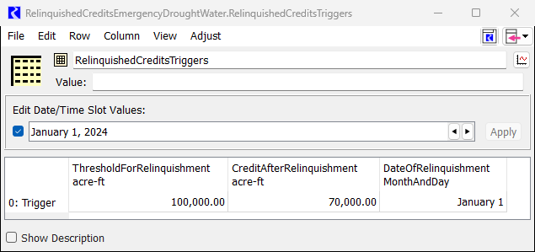

Figure 3‑20: Screen capture of RelinquishedCreditTriggers Table Slot

Follow-up allocations for storage of Emergency Drought water at El Vado Reservoir are distributed based on the proportions input to the ProportionsForNewEmergencyDrought WaterAllocationsByUser table slot (Figure 3‑21). Any initial allocations for storage from past relinquished credits should be included in direct input initial values in the MRGCDDroughtAllocation, SupplementalESAAllocation, and MunicipalitiesAllocation series slots. Allocations for the corresponding user are tracked with these slots during an URGWOM simulation. **Any water already in storage for the corresponding user still counts toward the allocation, so the initial allocations should be greater than or equal to any initial storage in these accounts on the ElVado reservoir object.** If initial values are not directly input, the initial allocation is set by the URGWOM rules to the amount of water already in storage for the corresponding user. When water is released, the allocation has been used and is then reduced. Maximum annual releases for MRGCD or ESA could be input to the MaxAnnualRelease table slot in the Relinquished CreditsEmergencyDroughtWater data object, but values of 99,999 acre-ft are currently input to effectively represent no annual release limit.

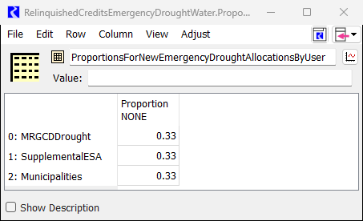

Figure 3‑21: RelinquishedCreditsEmergencyDroughtWater.ProportionsForNewEmergencyDrought WaterAllocationsByUser Table Slot

Coded policy for computing a relinquishment amount will be used if no value is input to the RelinquishedNMCredits series slot for the input relinquishment date. For planning studies, relinquished credits would be computed based on this policy if the switch for modeling relinquishments is set to 1.0. Compact credits will then be relinquished in URGWOM rulebased simulations on the input date for a relinquishment if the Compact credit exceeds the value (currently input as 100,000 acre-ft) in the ThresholdFor Relinquishment column in the RelinquishedCreditsTriggers table slot (Figure 3‑20) to reduce the credit to the value (currently input as 70,000 acre-ft) in the CreditAfter Relinquishment column in that same table slot.

#### Storage of Emergency Drought Water

Inflows of native Rio Grande water to El Vado Reservoir when Article VII is in effect are stored to separate accounts for Emergency Drought water *after* the final storage requirement for P&P needs is met first. A specific season for filling Emergency Drought water allocations can be set based on the dates in the PeriodToFillEmergencyDrought WaterAllocations table slot (Figure 3‑22). Storage accumulates in the Emergency Drought Water accounts with the actual inflow of native Rio Grande water. Available inflows of native Rio Grande water for Emergency Drought storage are split between the MRGCDDrought and SupplementalESA accounts based on the ratio of available allocation for the accounts. An allocation for storage of Emergency Drought water for municipalities is tracked in URGWOM but water is not currently stored for use by municipalities since exact policy for how such water would be used has not been defined.

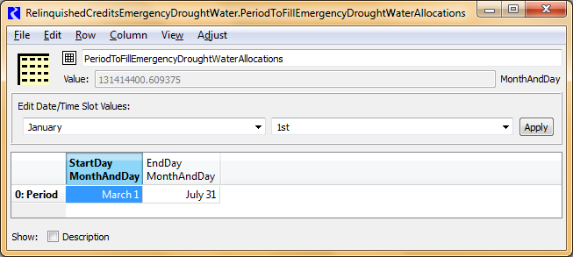

Figure 3‑22: PeriodToFillEmergencyDroughtWaterAllocations Table Slot

#### Releases of Emergency Drought Water

Water for MRGCD is tracked in an MRGCDDrought account on the El Vado reservoir object in URGWOM and is used to meet the MRGCD demand when native Rio Grande water is no longer available to meet the MRGCD demand at Cochiti but before any of MRGCD’s San Juan-Chama Project water is used. Emergency Drought water for meeting targets is tracked in the SupplementalESA account on the El Vado reservoir object and is used to meet targets before leased San Juan-Chama Project water in the Reclamation account at Abiquiu is used. A specific season for using SupplementalESA water can be defined in the ESAReleaseDates table slot in the RelinquishedCredits EmergencyDroughtWater data object; however, the entire calendar year is designated in the current model. A maximum release of SupplementalESA water can also be defined in the MaxESARelease table slot in the same data object, but this value is effectively not used in the current model as it is set to 9999 cfs.

### Cochiti Deviations to Provide Recruitment or Overbank Flows

Cochiti deviations are authorized through 2013 where the U.S. Army Corps of Engineers (Corps) may temporarily store native Rio Grande water at Cochiti Lake to then be released at the time of the peak and augment flows to provide recruitment flows in the Middle Rio Grande (Corps, 2009). Specific criteria are coded for identifying whether the runoff is sufficient to enact Cochiti deviations to provide recruitment flows (or overbank flows) but the runoff without deviations would be insufficient for providing the needed hydrograph by just bypassing inflows at Cochiti Lake. Operations entail providing overbank flows if conditions support providing the higher flows.

Cochiti Deviations can be turned on or off in URGWOM using the switch in the ModelDeviations(1=yes,0=no) column of the ModelUserControlTrigger table slot (Figure 3‑23) in the CochitiDeviations data object (Figure 3‑1). Another key input to review is the year for suspending this aspect for operations as input to the table slot called LastYearCochitiDeviationsAuthorized in the CochitiDeviations data object (Refer to Figure 3‑24 for a screen capture of this slot in the model). Current coded policy for deviations could be modeled for a period after 2013 by simply resetting this input to a later year. The input year should be reviewed against the model run period defined by the RiverWare Run Control.

Figure 3‑23: ModelUserControlTrigger Table Slot for Cochiti Deviations

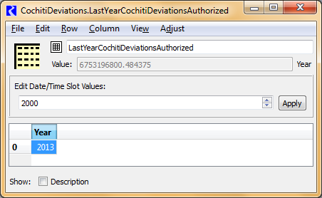

Figure 3‑24: MiddleValleyDemands.LastYearCochitiDeviationsAuthorized Table Slot

Deviations will be implemented to provide *recruitment* flows if the March through July Otowi flow forecast is between 50% and 80% of average and the projected peak inflow to Cochiti Lake during the recruitment or overbank season is between 1800 and 5000 cfs or the March through July forecast is greater than 80% of average but the projected peak inflow is less than 3500 cfs. The recruitment or overbank season is defined by the dates input to the RecruitmentOrOverbankSeasonDates table slot in the CochitiDeviations data object, and the projected peak inflow and the date of the peak into Cochiti is determined during a simulation and recorded to the EstimatedPeakInflow and EstimatedPeakInflow Date slots, respectively, in the CochitiDeviations data object. Deviations will be implemented to provide *overbank* flows if the Otowi forecast is between 80% and 120% of average and the projected peak inflow to Cochiti is between 3500 and 10,000 cfs or the Otowi forecast is between 50% and 80% of average but the project peak inflow is greater than 5000 cfs. These referenced fractions for the Otowi forecast as a percentage of average for identifying whether deviations should be implemented to provide recruitment or overbank flows are input to the EnvironmentalPercentages table slot in the CochitiDeviations data object. The average March through July Otowi flow volume is input to the AverageOtowiForecast scalar slot in the PandP data object (Note that this average Otowi flow volume is also referenced in a similar manner for evaluating whether the hydrology year type for setting target flows is dry, average, or wet as discussed in section 3.1.4.1). The threshold peak Cochiti inflow rates referenced when determining whether deviations should be implemented to provide recruitment or overbank flows are input to the EnvironmentalMinMaxPeakFlows table slot in the CochitiDeviations data object. Despite all the policy above coded in the URGWOM ruleset, it is also possible for a model user to override the coded criteria and force Deviations to provide recruitment or overbank flows by setting the corresponding switch in the ModelUserControlTriggers table slot (Figure 3‑23)

The date to start storage at Cochiti Lake for deviations can be input to the PresetDay ForCochitiDeviationsStorage table slot. If this option is used, the value in the Use PresetDayForCochitiDeviationsStorage column of the ModelUserControlTriggers table slot should be set to 1.0. If this option is used when the storage actually begins prior to the rulebased simulation Start Timestep (i.e. storage began in April for a AOP model run beginning May 1st), the Start Timestep for the rulebased simulation portion of the AOP model run should be input for the preset date to begin storage. If no preset date is input, the date to begin storage is set to 24 days before the projected date of the peak inflow to Cochiti Lake. The value for the number of days before the peak to begin storage is input to the DaysOfCochitiDeviationsStorageBeforePeak scalar slot in the CochitiDeviations data object. The amount of conservation storage is set with reference to the Otowi forecast and a lookup against the values in the RGConservationSpaceTable table slot. The designated target amount of conservation storage can also be input to the December 31 slot in the ComputedRGConservationSpaceAvailable series slot as an override to the lookup table.

Target flows to provide recruitment or overbank flows are input as 30-day target hydrographs in the EnvironmentalTargets table slot in the CochitiDeviations data object. If deviations are implemented, targets at Central are reset such that day five in the appropriate target hydrograph matches the date of the projected peak inflow to Cochiti Lake.

Water in storage for Cochiti deviations will be evacuated by the end of a deviations period which lasts for 45 days as input to the DurationCochitiDeviationsPeriod scalar slot in the CochitiDeviations data object. Water will begin to be evacuated 15 days before the end of the Cochiti deviations period at a constant rate if that constant rate is greater than the flow needed to meet the target in the established recruitment or overbank target hydrograph. A value of 3000 acre-ft is input to the LowStorageToEndDeviationsTargets scalar slot to shift Central targets back to original targets if storage at Cochiti for deviations drops below this threshold. This adjustment is needed to prevent other sources for supplemental water (i.e. leased San Juan-Chama Project water or Emergency Drought water) from being used to meet the recruitment or overbank targets established specifically for Cochiti deviations. Any needed adjustments to the coded policy for Cochiti deviations should only be implemented through coordination with the Corps and URGWOM Technical Team.

### Pumping from the Low Flow Conveyance Channel

URGWOM is set up to model pumping of flows from the Low Flow Conveyance Channel (LFCC) to the river to prevent river drying. Refer to Figure 3‑25 for a picture of pumps used to pump from the LFCC. Diversions at the Neil Cupp site, North Boundary of the Bosque del Apache National Wildlife Refuge, and South Boundary are simulated (Pumping at the Fort Craig site was determined to be inconsequential to URGWOM simulation results and is not included). Switches are set in the SwitchesForModeling PumpingAtEachSite table slot (Figure 3‑26) in the LFCCPumpingTriggers data object to turn on or off pumps at each of three sites (Refer to Figure 3‑1 for a screen capture of a portion of the URGWOM workspace with the LFCCPumpingTriggers data object).

If these pumps are enabled, water that seeps into the Low Flow Conveyance Channel is pumped to the river where pumping begins based on specific river flow triggers. Different triggers could be established as a function of the year classification for setting targets (section 3.1.4.1); although, the threshold low San Acacia flow triggers for initiating pumping at each site is the same in the current model regardless of the year type. The rate of pumping does vary based on year type. Values are input to the Dry, Normal, and Wet table slots (Figure 3‑27 to Figure 3‑29) in the LFCCPumpingTriggers data object. Different values are set up for the winter of wet years as defined by dates input to the WetSanMarcialWinterTarget SeasonDates table slot. After pumping has initiated at a site, pumping will continue for a minimum of one week and until the flow at San Acacia has exceeded 150 cfs as input to the SanAcaciaFlowTriggerForShutDown scalar slot in the LFCCPumpingTriggers data object. Pumping will cease for the year at each site after the dates for each site input to the DateToShutDownForYear table slot. It has been assumed for recent modeling that the pumps would not be used after July 15th. All the settings in URGWOM for this operation were refined as part of work for the PHVA Work Group of the Collaborative Program.



Figure 3‑25: Low Flow Conveyance Channel Pumps

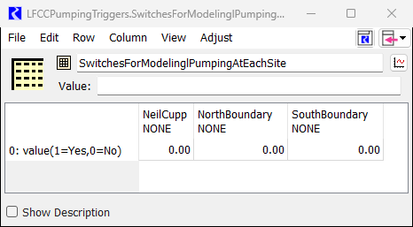

Figure 3‑26: Switches to Turn on LFCC Pumps in URGWOM Runs

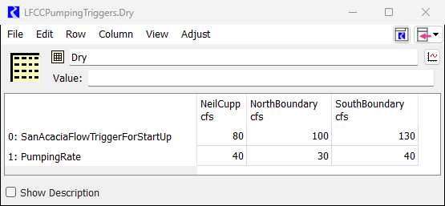

Figure 3‑27: LFCCPumpingTriggers.Dry Table Slot

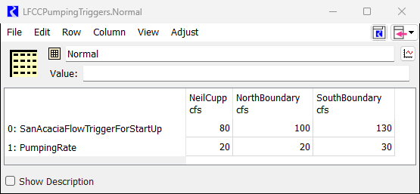

Figure 3‑28: LFCCPumpingTriggers.Normal Table Slot

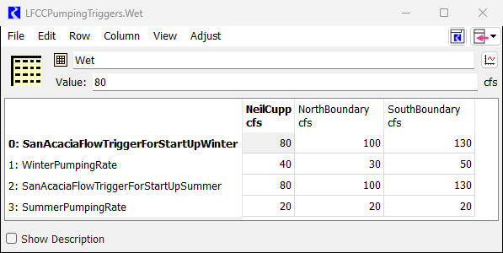

Figure 3‑29: LFCCPumpingTriggers.Wet Table Slot

### Reregulation Storage at Abiquiu, Cochiti, or Jemez Reservoir

Reregulation storage (also referred to as Conservation storage) at Abiquiu, Cochiti, and Jemez is not currently authorized and likely would not be included for an AOP model run unless such storage was actually implemented for an upcoming year. This aspect of policy is included in URGWOM for evaluation as part of long-term studies. Reregulation storage entails allowing storage at Cochiti or Jemez Reservoir or storage at Abiquiu Reservoir above the current maximum easement pool elevation of 6220 ft (although this may be increase to 6230, as described in section 3.2.1.1 above) as input to the SJCEasement column in the PoolLevels table slot in the AbiquiuData data object. If the total storage with reregulation storage at Abiquiu Reservoir was to be increased, this SJCEasement value should be adjusted accordingly (e.g. a value of 6277.18 would be input for a total storage of 500,000 acre-ft based on the elevation-capacity table). The value in the RGConservationSpaceAvailable table slot would then also be adjusted from zero to the total allowable storage to be modeled (e.g. 500,000 acre-ft). No additional conservation storage is allowed after that storage level has been reached. For Cochiti, the table slot is called FullTimeRGConservationSpaceAvailableNotRelevantToDeviations to distinguish this full time potential conservation storage amount from the temporary conservation storage that may be allowed as part of Cochiti Deviations as discussed in section 3.3.3.

Resulting reregulation storage allows storage of native Rio Grande inflows not needed to meet the MRGCD demand and is tracked with the Rio Grande Conservation storage account on the corresponding reservoir object in URGWOM. Reregulation storage is then released as needed for targets and is used before any supplemental water is used that may be available from Reclamation leases or as Emergency Drought Water. Reregulation storage still in storage within the dates input to the RGConservationRelease Days table slot is completely evacuated at a computed constant rate (Past studies have also included an alternate coded policy to only evacuate reregulation storage as needed to keep the Compact credit whole). Coded policy for reregulation storage would likely need to be reviewed with the URGWOM Technical Team and the Corps if such an operation were to be modeled.

* Note that Cochiti Deviations and full time conservation storage at Cochiti can both be modeled at that same time where available space for conservation storage from Deviations would reduce to the full time space available after Deviations policy is completed during a runoff.

# General Set Up for Use of URGWOM

A few important aspects of the setup of URGWOM and the configuration for a model user’s machine are reviewed before presenting steps for setting up applications. Before the established DMIs in URGWOM can be used to import data to the model, Environment Variables must be set up on the model user’s machine that identify the location of database files. The latest database file must also be obtained and placed in a specific location on the model user’s machine. Excel data files and existing RiverWare SCTs may also be needed.

## Database

The URGWOM historical database is maintained in several files that have the format of the Corps’ Hydrologic Engineering Center Data Storage System (DSS). A separate Hydrologic Database (HDB) is under development by Reclamation and is currently being used for daily use of the Accounting Model application. Contact Reclamation for more details on the HDB database and the status of the associated DMIs used with the Accounting Model application. DSS DMIs can be used by anyone and simply require the Environment Variable to be defined on the model user’s machine identifying the location of the database file. Datasets in URGWOM referenced by the DMIs specifically reference the DSS filename.

For completing planning runs, the database may be accessed by DMIs in URGWOM to import series inputs needed for rulebased simulations. The database file is also needed to update RiverWare data objects in URGWOM that contain a portion of the URGWOM database. Data in those objects are referenced by Initialization rules for the applications of URGWOM.

** Prior to working with URGWOM, it should be confirmed that the name of the latest DSS file (e.g. URGWOMDatabase_June2024.dss) matches the filename referenced in all the DSS datasets used by the established DMIs in URGWOM.

The DSS database file contains all data back to 1975 (1950 in some cases) needed to complete rulebased simulations using the historical hydrology or for modeling historical operations in regular simulation. In addition to all the required series inputs, values are included in the database as needed for initial conditions for model runs for historical operations. To simplify database administration and use of the database file with URGWOM, extraneous data not needed to run URGWOM are not included. Each record in the DSS file has B part and C part information that matches the target RiverWare object and slot name, respectively, in URGWOM. All records represent historical data except for a few records with “projected” values for deep aquifer heads, lumped crop evapotranspiration (ET) rates, irrigated areas, and riparian areas. These projected records are stored with different B part and C part information that match slot names for separate projected series data objects.

## Environment Variables

Environment variables should be set up on a model user’s machine to use the established DMIs, rulesets, SCTs, URGWOM, and these variables should be checked. The URGWOMDSS Environment variable should reference the location on the model user’s computer containing the two URGWOM DSS databases. The URGWOMExcel environment variable should reference the location containing the spreadsheet file used to import initial conditions for planning runs (refer to section 4.3.3), and the template spreadsheet file used for reviewing output from AOP model runs. The URGWOMSCT Environment variable should reference the location on the model user’s computer containing the applicable SCTs listed in URWOM Documentation Volume 5. Finally, the URGWOMRPL Environment variable should reference the location on the model user’s computer containing the most recent URGWOM ruleset.

Environment Variables are set up on a model users machine by going to the Control Panel – System and Security – System – Advanced System Settings and selecting Environment Variables on the Advanced tab:

Figure 4‑1: Screenshot of URGWOM Environment Variables setup on a model user's machine

## DMIs

RiverWare DMIs are used in URGWOM to import or export data from databases to or from URGWOM. The DMIs are accessed through the DMI menu in RiverWare. If a specific DMI is selected under the RiverWare menu, the DMI will be invoked to export or import data. DMIs can be viewed and edited with the DMI Manager in RiverWare. DSS DMIs are set up for importing historical data into URGWOM for completing a rulebased simulation planning run using the historical hydrology or for setting up a simulation for historical operations. HDB DMIs are used with the Accounting Model application, and Excel database DMIs are used for importing data from formatted Excel spreadsheets and are also used to export data to template spreadsheets for reviewing output from URGWOM runs.

HDB can only be accessed through Reclamation’s system and requires an account with HDB and a setup configured by Reclamation.

### DSS DMIs

Three DMIs are typically used in URGWOM for importing data from the DSS database file:

* ImportHistoricalAndProjectedData_fromURGWOMDSS
* InputSeriesForHistoricalSimulation_fromDSS,
* InitialConditionsForSimulationOfHistoricalOps_fromDSS.
* InputSeriesForHistoricalSimulation_fromDSS_COPortion

The first DSS DMI is used to import series inputs for AOP and Planning. The last three DMIs are rarely used for model calibration or to develop new residuals at local inflow nodes in URGWOM for updating ungaged local inflow records in the database. DMIs are discussed further in URGWOM Documentation Volume 5: DMI and SCT.

### HDB DMIs

Three HDB DMIs are typically used for importing and exporting data from the Accounting Model application of URGWOM from and to HDB:

* InputBOYAccountingFromUCHDB2,
* InputDailyAccountingFromUCHDB2, and
* OutputAccountingToUCHDB2.

The first DMI is used to import initial conditions to an Accounting Model application for a new year. The second DMI is used each day to import actual recent data to the Accounting Model for updating the Accounting Model runs. Data and simulation results are then exported to HDB each day from Accounting Model runs with the Output AccountingToUCHDB2 DMI. Reclamation has continued to develop HDB and the DMIs for use with the Accounting Model, so the latest status of the DMIs should be checked with Reclamation.

### Excel DMIs

Two Excel DMIs are typically used in URGWOM for importing initial conditions for a planning run or for exporting output from an AOP model run to a template spreadsheet for reviewing output:

* InitialConditionsForRulebasedSimulation_fromExcelFile and
* AOPRunOutputForTemplateSpreadsheet_Excel.

When planning runs are set up using hydrologic data for a historical period imported with InputSeriesForRulebasedSimulation_fromDSS DMI, required initial conditions are imported with the separate InitialConditionsForRulebasedSimulation_fromExcelFile DMI. Initial conditions would be developed specific for the study, likely based off recent conditions, and set up in an existing template Excel file called URGWOMInitial Conditions.xlsx. This file should be obtained from URGWOM Technical Team files by any model user that will be setting up such a planning run.

A template Excel spreadsheet (WaterOperationsOutputTemplate_forURGWOM.xls) is available for reviewing output from AOP model runs. Output from an AOP model run is exported to the template with the AOPRunOutputForTemplateSpreadsheet_Excel DMI. Numerous plots in the template spreadsheet will automatically update after output from a new AOP run is exported to the spreadsheet with the DMI.

A third Excel DMI called WWCRA_Excel is also included in URGWOM that was used for a particular study for the West Wide Climate Risk Assessment (WWCRA). This DMI could potentially be useful as a means for importing hydrologic data to URGWOM obtained from a completely separate database; thus, the DMI was retained in URGWOM. Excel DMIs have been very useful and valuable for meeting the needs for exporting or importing a select series from or to URGWOM for a particular applications or for a special project.

# Steps to Manually Set Up URGWOM for Applications

Details and steps are presented below for setting up the model for the primary applications of URGWOM. Most of these steps are now automated within the Scripts listed above in sections 1.4 and 1.5, but some URGWOM users may be interested in how to set up these model applications manually.

For the Accounting Model application, information on setting accounting supplies and annotations are presented followed by specific steps for setting up a model for a new year and for completing daily Accounting Model runs. For the AOP model application, steps are presented for using the latest Accounting Model to set up a combined Accounting Model run followed by a rulebased simulation for an AOP run. Separate steps are listed for a AOP model user to review for potentially controlling how forecast hydrographs are generated. Some specific slots in the model to check are also listed along with some notes on an existing template output spreadsheet for reviewing AOP model run results. For the Planning Model application, steps are included for setting up a planning run using the latest Accounting Model and hydrology defined by a table in the model or by importing initial conditions and series inputs for a planning run with DMIs. Finally, steps are presented for setting up a regular simulation, without rules, for historical operations using DMIs and the DSS database file.

## Accounting Model

The discussion in section 2 should be reviewed before new users work with an Accounting Model application. That discussion includes background information on how daily operation decisions are made with consideration for the various key aspects of operations. The discussion below includes more details on actual model use including the steps to set up and run the model and the approach for setting accounting supplies and adding notes about individual deliveries.

### Setting Accounting Supplies

After stream gage data, diversions, and total outflows have been input with the HDB DMI and SCT using the steps listed in section 5.1.1, accounting supplies are set for the individual deliveries of water for contractors for San Juan-Chama Project water and other users. A list of accounting supplies for the movement of water from each storage account at each reservoir is accessed in RiverWare by selecting the Accounts tab for a reservoir object, opening the storage account of interest, and double clicking on any cell in the Outflow column (Refer to Figure 5‑1 for a sample list of accounting supplies from the Albuquerque (i.e. ABCWUA) storage account at Abiquiu Reservoir). If only one supply exists from a storage account, the single accounting supply is set directly to the Outflow series for the storage account. If the Outflow series is not evident when double clicking on the account to Edit the account, right click on the account and select Open Account to find the Outflow series for the storage account.

The nomenclature for the column headings when setting a supply from a selected storage account is the destination object, which is the next downstream object in the model for deliveries downstream or the reservoir object for accounting transfers within a reservoir, followed by the name for the destination account. For a transfer within a reservoir, the destination account is the name of the destination account. For a delivery downstream, the destination passthrough account is named based on the following format: Contractor Name-Origin-Contractor Name-Destination. For example, the account with a name of AlbuquerqueAbiquiuToSurfaceWaterDiversionAlbuquerque WaterUser is the account name representing the downstream movement of water from the Albuquerque account at Abiquiu Reservoir to the SurfaceWaterDiversion diversion account on the AlbuquerqueWaterUser object.

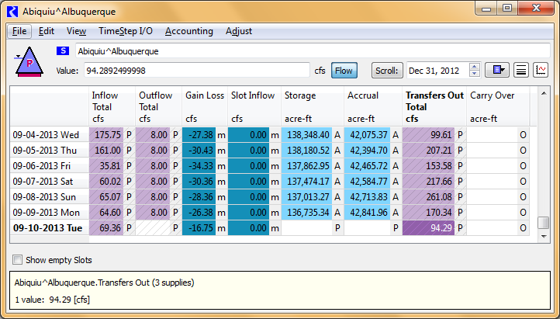

Figure 5‑1. Screen Capture of Sample Inputs for Accounting Supplies – for the Albuquerque Account at Abiquiu Reservoir

For a given day within a year, accounting supplies are usually only set for a few specific deliveries, but several accounting supplies are set throughout the year including supplies for the following deliveries: Contractors for San Juan-Chama Project water may transfer water to Reclamation’s account as a result of a lease. Contractor water may be moved from storage at Heron Reservoir to El Vado and/or Abiquiu Reservoir. ABCWUA deliveries to their surface water diversions are set out of Abiquiu Reservoir with separate accounting supplies for the payback for historic and current groundwater pumping, and other contractors may also have letter water deliveries. MRGCD will deliver their San Juan-Chama Project water from El Vado Reservoir to meet their diversion needs in the Middle Valley, generally after native Rio Grande supplies have been exhausted.

In addition to deliveries of San Juan-Chama Project water, the model user sets accounting supplies for the transfer of native Rio Grande water in storage at El Vado Reservoir to be transferred to the PandP account for P&P storage or to the SupplementalESA or MRGCDDrought accounts as Emergency Drought water. Releases of native Rio Grande water at each dam are reconciled during the simulation based on the input total outflow minus all the input accounting supplies for the release of San Juan-Chama Project water at each reservoir and releases to other users.

#### Example for Setting an Accounting Supply

An example is presented for how an accounting supply would be set in the Accounting Model for a delivery of Albuquerque San Juan-Chama Project water from their storage at Abiquiu Reservoir to their surface water diversion. For this example, it was previously determined that Albuquerque is requesting a release of 8 cfs of their San Juan-Chama Project water from Abiquiu Reservoir. This may be determined from a spreadsheet provided by ABCWUA (reference Appendix C – Sample Sheet with ABCWUA Water Needs for Diversion) or through direct communication with ABCWUA or during water operations conference calls conducted with all parties involved in Rio Grande water operations. Note that for an 8 cfs release, the amount of San Juan-Chama Project water available at the surface water diversion would be 7.44 cfs after considering the San Juan-Chama loss rates from Abiquiu to Cochiti and from Cochiti to the surface water diversion. The total physical diversion would be 14.89 cfs with the additional equal portion of native Rio Grande water diverted for the 50 percent return flow credit from the wastewater treatment plan returns to the river.

To set the 8 cfs delivery from Abiquiu Reservoir, the Albuquerque account would be opened by opening the Abiquiu level power reservoir object, selecting the Accounts tab, and double clicking on the Albuquerque storage account to Edit the account. Scroll to the timestep for the delivery to be set, likely the last timestep in the latest Accounting Model run. Double click on the Outflow cell. The total outflow for the account is shown with four separate accounting supplies for different potential individual deliveries (Figure 5‑2). The accounting supply for the delivery to the surface water diversion can be identified based on the naming convention and is the first supply listed after the total outflow. The delivery to the surface water diversion is input for that supply for the appropriate timestep.

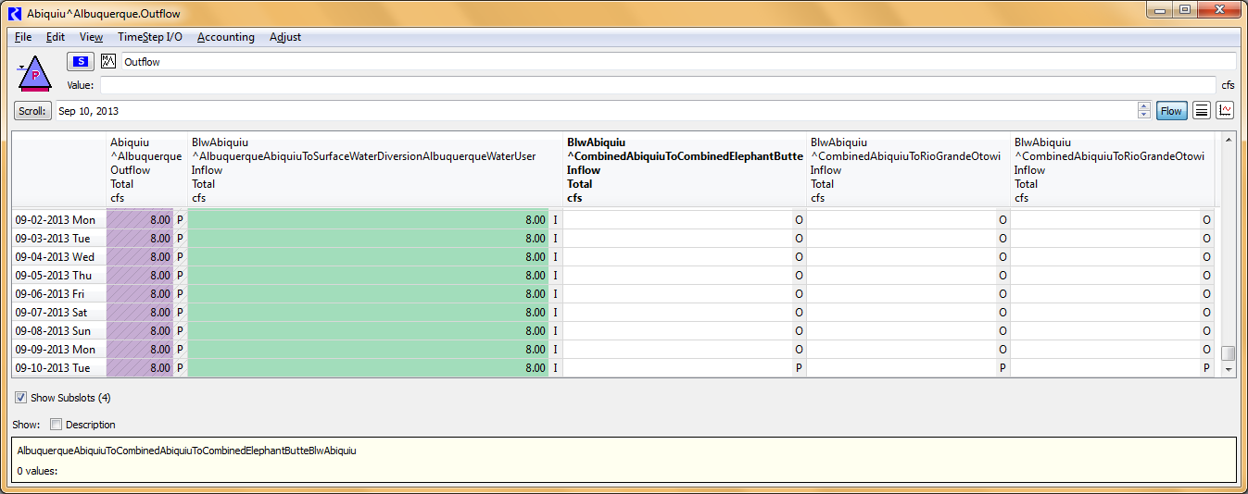

Input delivery of 8 cfs from the Albuquerque account at Abiquiu to the Albuquerque surface water diversion for the latest timestep.

Figure 5‑2: RiverWare Dialog for Total Outflow from the Albuquerque Account on the Abiquiu Reservoir Object and Individual Accounting Supplies

#### Example for Setting Two Accounting Supplies for Delivery of Contractor Water through Combined Passthrough Accounts

Accounts in URGWOM are set up for tracking projected individual deliveries. Specific accounts are set up for modeling the movement of water from Heron Reservoir to El Vado or Abiquiu Reservoir for Albuquerque, MRGCD, Cochiti Rec Pool, Santa Fe City, and Santa Fe County. Other contractors for San Juan-Chama Project water only use their water for letter water deliveries or lease their water to Reclamation and movement of their water is less common. To reduce the size of the URGWOM model file and allow for the same single model file to efficiently be used for all applications of URGWOM, a single chain of passthrough accounts is included and used for water moved for other contractors. For these accounts, an accounting supply is first set for the delivery to the single chain of Combined passthrough accounts and a second transfer accounting supply is set to transfer the water back to the contractor’s account at the downstream reservoir.

As an example, assume Los Alamos is going to deliver water from their storage account at Heron Reservoir to their storage account at Abiquiu Reservoir. A delivery of 10 cfs out of Heron is needed. Open the Heron storage reservoir objects, select the Accounts tab, and open the Los Alamos account to Edit the account. Double click on the Outflow for the account for the appropriate timestep (If the Outflow is not shown, on the Accounts Tab on the Heron object, select Open account on the Accounts menu for the Los Alamos account and double click on the Outflow slot). Two supplies are shown after the total outflow for the account. Set the supply for the 10 cfs delivery to Abiquiu Reservoir which can be identified based on the accounting supply naming convention (Figure 5‑3).

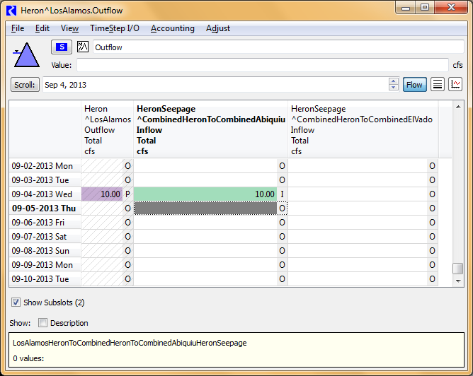

Figure 5‑3: RiverWare Dialog for Total Outflow from the Los Alamos Account on the Heron Reservoir Object and Individual Accounting Supplies

A second accounting supply is set to transfer the water from the Combined storage account on the Abiquiu level power reservoir object to the Los Alamos storage account. The transfer is set with consideration for San Juan-Chama lags and loss rates. There is a one day lag from Heron to Abiquiu Reservoir, and the transfer is 9.89 cfs after considering the losses (see the BlwElVadoToAbvAbiquiu^CombinedHeronToCombinedAbiquiu.Gain Loss Coefficient value of 1.1%). Open the Abiquiu level power reservoir object, select the Accounts tab, and open the Combined account to Edit the account. Double click on the Transfers Out for the account for the timestep (If the Transfer Out slot is not shown, on the Accounts Tab on the Abiquiu object, select Open account on the Accounts menu for the Combined account and double click on the Transfers Out slot). Transfer supplies are shown to transfer water to the different contractors. Set the transfer supply to move water to the Los Alamos account to 9.89 cfs (Figure 5‑4).

The Transfer In will be evident on the Los Alamos account on the Abiquiu object, and the storage in the Los Alamos account will show the water moved into the account from Heron via the single chain of combined passthrough accounts. The configuration and approach for considering lags and losses can be checked after a simulation is completed. The same approach would be used for moving contractor water through the single chain of passthrough accounts to El Vado or from El Vado to Abiquiu or from Abiquiu to Elephant Butte Reservoir. It should also be emphasized that water could be transferred from one contractor’s upstream storage account to a different contractor’s downstream storage account using a similar approach.

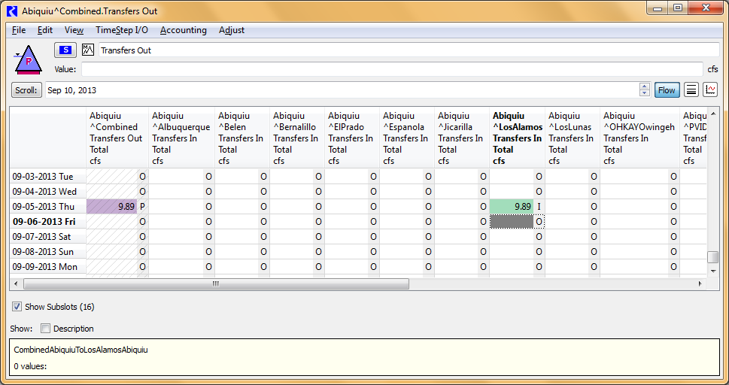

Figure 5‑4: RiverWare Dialog for Transfers Out Slot on the Combined Storage Account on the Abiquiu Reservoir Object and Individual Transfer Accounting Supplies

### Green Book Entries as Annotations in Accounting Model

All deliveries of San Juan-Chama Project water have historically been noted on pages in a handwritten log of operations at Reclamation referred to as the Green Book. These notes include details of the volume magnitude, source, and destination for any deliveries or exchanges. Functionality is included in RiverWare to include these notes within an Accounting Model file as annotations. All Green Book entries should be recorded and kept within the model file. Instructions are presented below for setting up annotations with the notes for deliveries of San Juan-Chama Project water as written in the Green Book.

The following steps should be followed to complete the initial set up of the Note Group Manager in the Accounting Model if not already established:

1. Click on Note Group Management under the menu list for Utilities in the model.
2. If needed, click on the button in the upper left corner to show all the Note Groups.
3. Use the Create Note Group button to add separate note groups.

A screen capture of how note groups should look in the Note Group Manager is presented in Figure 5‑5. Different colors can be selected to use for the note icon for each group if desired. The groups are sorted in alphabetical order.

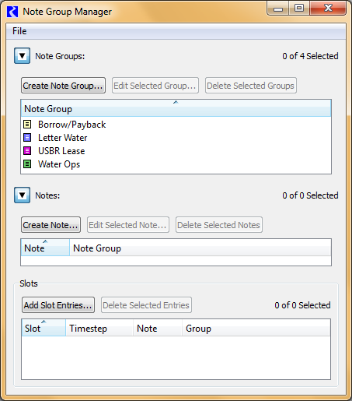

Figure 5‑5: Screen Capture of Note Group Manager with Note Groups

Data objects are included in the Accounting Model that contain expression series slots for computing the total daily inflow and outflow to the storage accounts at each reservoir for each contractor for San Juan-Chama Project water. Notes about deliveries should be set up on the expression series slots. These expression slots can then be referenced in Tabular Series Slot Reports generated in the Output Manager in the model accessed under the Utilities in the menu. These Tabular Series Slot Reports can be configured to match the format for pages in the current hard copy Green Book so configured pages can be printed and saved in the hard copy Green Book.

The following steps should be followed to set up a note:

1. Identify the location for a particular delivery to be tagged with a note in the inflow or outflow expression series slot within the Green Book data object for the contractor and reservoir.
2. Select only the first slot for the range in the series when the delivery occurs.
3. Right click and select Add Note…
4. Within the Note Group Manager that opens, select the appropriate Note Group.
5. If needed, click on the button next to Notes to open the section for creating a note (Reference Figure 5.5 for a screen capture of the Note Group Manager).
6. Click on the Create Note button.
7. Type the note with a description of the delivery (Refer to Figure 5‑6 for sample language for a note).

* The note can also be edited after first created by clicking on the Edit Selected Note button where the original note is displayed followed by a window for entering a new note to be used.

1. Click on the Add Slot Entries button and select the particular slot in the appropriate data object where the note should be located.

* For this approach, notes are not tagged to the specific accounting supply or the storage account outflow slot for the reservoir object. The notes are maintained on the established data objects developed specifically for creating the Green Book pages.
* Under Timesteps, select the timestep at which the annotation should be posted.
* Only one note is needed, so the annotation should only be tagged to a single first timestep for the range that the delivery occurred – leave the box to Apply Over Timestep Range unchecked.
* Click OK
* Refer to Figure 5‑7 for a screen capture of the Note Group Manager with a sample note created.

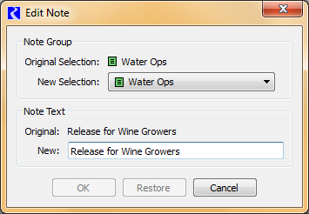

Figure 5‑6: Sample Dialog to Edit a Note

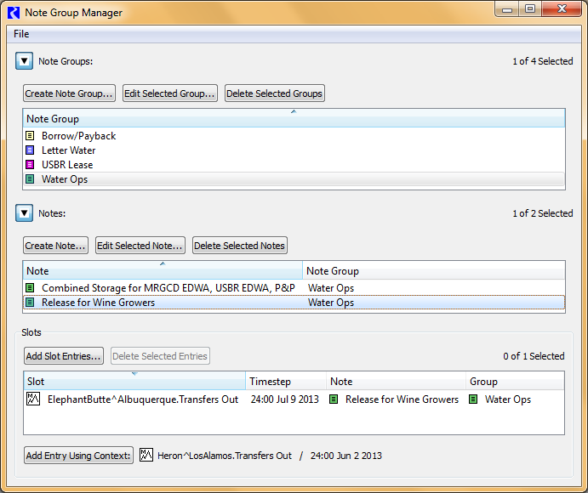

Figure 5‑7: Note Group Manager with Sample Note Created

An icon for the note will now appear on the slot referenced for the note at that selected timestep. Separate notes should be set up for each delivery (or transfer) that occurs by repeating the steps above.

### Steps to Set Up Accounting Model for a New Year

The following steps should be completed to set up a new Accounting Model for a new year. Due to the need to obtain December 31 initial conditions from the Accounting Model run completed at the end of the previous year, the following steps should be completed after that final simulation has been completed on January 1. Note that the model user must have access to Reclamation’s HDB database to complete these steps. Note that these steps have been incorporated into scripts to help users do these steps automatically.

1. Open the last Accounting Model run for the previous calendar year (e.g., Final_Account_9.2_2023.mdl.gz).
2. Use the Save As option in RiverWare to save the model with a new name that maintains the URGWOM version number and contains the new year for the model (e.g. Account_9.3_2024.mdl.gz). (Note that the file name is significant for scripts that run on the Corps’ system to pull the model, with a specific name, to the Corps system each time it is saved at Reclamation.)
3. Reset the Run Control to have a Start Timestep of January 1 of the new year, and a Finish Timestep of Yesterday’s date.
4. Reset the Accounting Period to exactly match the Run Control period – select Accounting – Accounting System Configuration – set the Begin Accounting Period date to January 1 of the new year and set the End Accounting Period to Yesterday’s date.
5. Synchronize Objects to the new Run Control Period – select Workspace – Objects – Synchronize Objects – Check the box to Include Accounting Objects and the box to Exclude Slots with Different Timesteps from Run.
6. Assure the value in the ModelTrigger_1forAccount_2forAOP_3forPlanning_ 4forHistorical scalar slot is set to 1.0.
7. Assure the controller in the Run Control is set to Inline Simulation and Accounting.
8. Invoke the InputBOYAccountingFromUCHDB2 DMI to import initial conditions from HDB – values were exported to HDB from the Accounting Model for the previous year with the OutputAccountingToUCHDB2 DMI.
9. Proceed to steps listed in section 5.1.4 to begin using the model for the new year.

A script has been created to follow these steps as actions that are automated and greatly reduce the time it takes to set up a new year account model. Figure 5‑8 is a screen capture of the Accounting Application Run Setup for New Year from Previous Model Run (HDB database) dashboard.

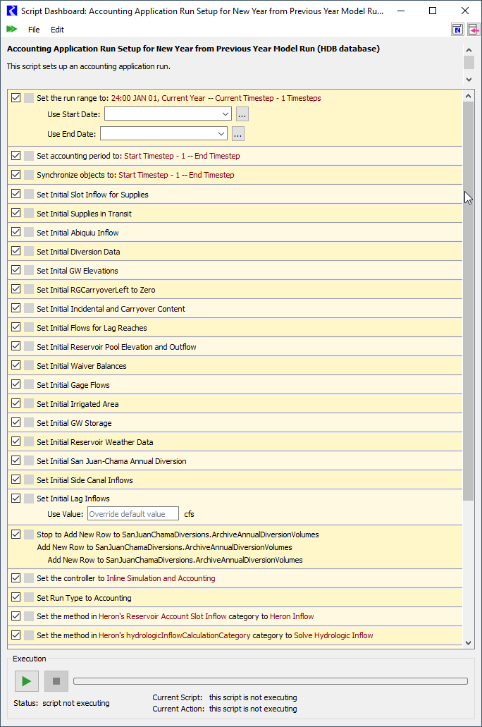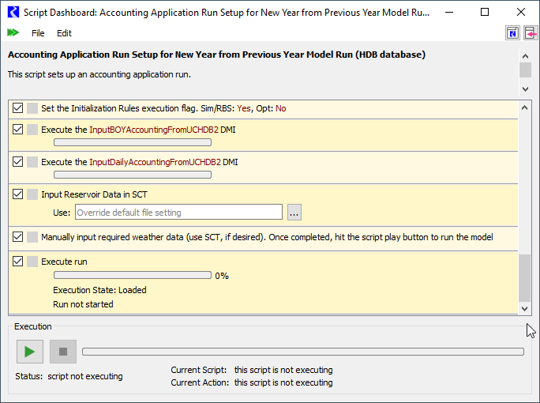

Figure 5‑8: Screen Capture of Accounting Application Run Setup for New Year from Previous Model Run (HDB database) dashboard

### Steps to Complete Daily Accounting Model Runs

The following steps should be completed to run the Accounting Model each day on Reclamation’s system (the model user must have access to Reclamation’s HDB database).

1. Start RiverWare and open the current Accounting Model file.
2. Reset the Run Control to have a Finish Timestep of Yesterday’s date (and retain the Initial Timestep of December 31 of the previous year).
3. Run the InputDailyAccountingFromUCHDB2 DMI.
4. Open the SCT for directly entering data – On the menu bar, select Utilities – SCT – Open SCT – locate and open the DataSCT_forAccountingModel .sct.gz file.
5. Fill in or edit reservoir data and other values included in the SCT as needed. Refer to Appendix B – Sample Fax Sheet with Reservoir Data with data that must be hand-entered using the SCT.
6. Set all the accounting supplies as needed for individual deliveries since the last completed Accounting Model run (Refer to Section 5.1.1 for discussion on how to set accounting supplies). Refer to Appendix C – Sample Sheet with ABCWUA Water Needs for Diversion for a sample of information that must be input.
7. Run the model
8. Check the resulting Rio Grande releases and storage at each reservoir and make any required adjustments and rerun the model as needed.
9. Input annotations in the model using the instructions provided in Section 5.1.2.
10. Run the OutputAccountingToUCHDB2 DMI.
11. Save the model and close the application for the day when complete.

## AOP Model

Steps are presented below for setting up an initial AOP model run starting with the latest Accounting Model followed by a separate list of steps for reviewing the initial run and making adjustment for controlling how forecast hydrographs are generated. Initial conditions are provided with the Accounting Model portion of a combined Accounting Model run followed by a rulebased simulation for an AOP model run. A third list is presented with specific user controls for different aspects of operations that should be reviewed in an AOP model run.

### Steps to Set Up Initial AOP Model Run

The following initial steps should be followed to set up an AOP model run from the latest Accounting Model:

1. Set the ModelRunTriggers.RulebasedSimulationStartDay to the next date after the last date of simulation for the current Accounting Model run (e.g. if the Accounting Model Run Control period is set to January 1 through April 6, set the RulebasedSimulationStartDay slot value to April 7 of that same year).
2. Set the period in the Run Control dialog to still start on January 1 but with a finish timestep of December 31 of the current year.
3. Reset the controller in the RiverWare Run Control dialog to Inline Rulebased Simulation and Accounting.
4. Set the value in the ModelRunTriggers.ModelTrigger_1forAccount_2forAOP_ 3forPlanning_4forHistorical slot to **2** to indicate an AOP model run.
5. Input NRCS forecast information to the appropriate table slot (e.g. ForecastFebruary for the February forecast) in the InputForecastData data object.
6. Set the value for the forecast to run (i.e. 10, 30, 50, 70, or 90) in the SingleRunNRCSForecast scalar slot.
7. Change the Reservoir Account Slot Inflow accounting method on the Heron reservoir object to Zero Slot Inflows.
8. Change the hydrologicInflowCalculationCategory method on the Heron reservoir object to Hydrologic Inflow and Loss.
9. Reset all the Inflow values on the AbvHeron stream gage object to output.
10. Check parameters for all aspects of operations (Refer to section 5.2.3 and the entire discussion in section 3).
11. Open and load the URGWOM ruleset. (While only one master ruleset is maintained for use for all applications of URGWOM, the appropriate ruleset should be used that corresponds with the version of the URGWOM model file being used or the ruleset that may have been potentially specifically adjusted for the current modeling.)
12. Run the model.
13. Save the AOP model with a name that designates the month of the forecast simulated and the associated exceedence percentage (e.g. 50 percent, 30 percent, etc.) for the referenced forecast.

### Steps for Model User Control of Forecast Hydrographs

After a combined Accounting Model run followed by a continued rulebased simulation for an AOP model run is set up using the steps in section 5.2.1, the following steps should be completed to review potential needed edits to parameters for users to adjust the approach for how forecast hydrographs are generated (the slots referred to below are in the InputForecastData data object, unless otherwise stated):

1. Adjust values in the ReferenceYearForOtherURGWOMInputLocationsMapped ToForecastLocation table slot as needed.
   * Several additional inflow locations are included in URGWOM in addition to the NRCS forecast locations. For these other inflow locations, forecasts are developed by using the same historical year that is selected for one of the NRCS forecast locations and the same ratio applied to the historic data as used to match the forecast for the NRCS forecast location. The mapping between the other inflow locations in URGWOM and an NRCS location is identified by the model user with this table.
2. Input values in the SwitchToStipulateRunoffTiming table slot in the InputForecastData data object if there is interest in forcing the model to produce a forecast with an early, average, or late runoff.

* Specific years that have either an early, late, or average timing for the runoff are already input to the DesignatedYearsForDifferentRunoffTiming table slot. Note that some alternative years with early, average, or late runoff are also already stored in this table in rows with label names that start with Other, so the input values in the Early, Average, and Late rows could be adjusted to these other values if desired. The corresponding trigger value should be input to the SwitchToStipulateRunoffTiming table slot if a defined timing for the runoff should be used.

1. Input values in the SwitchToUseHydrologicCategoryYearForPreForecastPeriod and SwitchToUseHydrologicCategoryYearForPostForecastPeriod table slots if there is interest in forcing the model to use data from either a dry, average, or wet year for the corresponding forecast period.

* Specific years that were dry, average, or wet are input to the PreForecast DesignatedHydrologicCategoryYears and PostForecastDesignated HydrologicCategoryYears table slots for the forecast locations identified by the column labels in each table. The switches should be set as follows if the corresponding input years should be used for a forecast location: 0 for Dry, 1 for Avg, 2 for Wet, and a NaN for no stipulation.

1. Input values in the UserInputYearsToUseForPreForecastPeriod, UserInput YearsToUseForForecastPeriod, and UserInputYearsToUseForPostForecastPeriod table slot should be set if desired to use a specific historical year for the corresponding forecast period and forecast location.

* These inputs allow the model user to override a determined closest year by URGWOM with a specific historical year.

1. The user can set date of peak and peak flow rate during the forecast period. This is done by inputting values in the UserSetSyntheticHydrographs data object in the UserInputPeakInflowAndDateForForecastPeriod table slot. The user also sets values in the appropriate …PercentOfPeak table slots for each forecast location to shape the hydrograph however the user desires.

* The switch to turn on this option must be set in the UserSetSyntheticHydrographs.TriggerForUserInputPeakHydrograph_0forOff_1forOn scalar slot.

1. The user can shift an historical hydrograph within the forecast period to get the desired timing of the hydrograph based on judgment of the user. This is done by inputting values into the ShiftedHydrographs data object in the ShiftHistoricalHydrograph table slot, by either inputting in the date the user would like the peak to occur, or by inputting the number of days to shift forward or backward from the current peak date (a negative value shifts the hydrograph forward and a positive value shifts the hydrograph backward).

* The switch to turn on this option must be set in the ShiftedHydrographs.TriggerForShiftingHistoricalHydrograph_0orNANforOff_1forOn scalar slot.
* An optional switch (ShiftedHydrographs.TriggerForShiftingHistoricalHydrographForEntireYear_0orNaNforOff_1forOn) can also be set to shift the hydrograph for the entire year and not just for the forecast period.

1. Set inputs to the LocalInflowsDistributionToMatchOtowiForecast table slot as desired.

* Inputs to this table allow for forecasted ungaged local inflows for each location in the table to be weighted higher or lower relative to the other forecast locations while always matching the Otowi forecast regardless of the values (with some slight error due to estimated loss rates used to match the forecast).

1. Adjust values in the RatioToAdjustPreForecastSeasonLocalInflowsNotImpact Otowi, RatioToAdjustForecastSeasonLocalInflowsNotImpactOtowi, and RatioToAdjustPostForecastSeasonLocalInflowsNotImpactOtowi (greater than 0).
   * Forecasted ungaged local inflows for locations below Otowi are set in URGWOM using the same forecast ratio for the forecast location identified in the ReferenceYearForOtherURGWOMInputLocations MappedToForecastLocation table slot. Those determined forecasted local flows flow locations below Otowi can be adjusted by the model user with the input ratios that represent a percentage of the URGWOM determined forecasted flows. A value of 0 would yield no local inflow for the location and associated forecast period, and a value of 1.0 would yield no change from the forecasted local inflows. A value of 0.8 would reduce the forecasted local inflow values by 20 percent. A value of 2.0 would double the forecasted flows.
2. Adjust the value in the BlendingRatio table slot if needed (ranging from 0 to 1).

* The switch to turn on this option must be set in the InputForecastData.SwitchToBlendForecastHydrographs table slot.
* The forecast flows may be adjusted to prevent abrupt changes in the last observed flow from the pre-forecast period and the first flow for the forecast period. If the absolute value of the difference in the flows divided by the last pre-forecast flow exceeds the input value in the Blending Ratio slot, then the first three forecast flows are adjusted to provide a ramp up or ramp down over the first three days of the forecast period.

1. Adjust the Value in the AzoteaWillowFractionContributionToElVadoInflow Forecast as needed.

* The forecasted inflow at El Vado is distributed between Willow Creek and the local inflow at El Vado based on the input percentage (e.g. 6% and 1 minus that percentage for the local inflow at El Vado (94%)).

1. No change to the values in the LittleNavajoRegressionCoeff table slot should be needed.

* These values were generated based on historical data for developing a forecast for the Little Navajo River as a function of the forecast for the Rio Blanco.

1. Adjust the values in the NumberOfClosestYearsToAverageForAOPruns table as needed.
   * This table controls how many years of historical data are averaged for each period in the AOP run (pre-forecast, forecast, and post-forecast).

### Review of Rulebased Simulation Controls and Results for Different Aspect of Operations

Parameters for all aspects of operations in an AOP model run (or planning run) should be reviewed as discussed in section 3. The following slots are listed as a few specific locations that should be specifically reviewed at a minimum in the context of the associated aspect of operations and against the assumptions for the AOP model run (or planning run) being set up. The section in this user manual with more information on the associated needed inputs is noted in parentheses.

* + All settings in all the table slots in the LeaseData data object (Section 3.3.1);
  + All settings in all the table slots in the LetterWaterDeliveryData data object (Section 3.1.3);
  + Values in the SwitchesForModelingPumpingAtEachSite and DateToShut DownForYear table slots in the LFCCPumpingTriggers data object (Section 3.3.4);
  + Values in the MRGCD.StorageToConserve periodic slot (Section 3.1.1.1);
  + Value in the TriggerIncreaseAngosturaDiversionsForPandPOps table slot (Section 3.1.1.3);
  + Value in the TriggerImplementArticleVIIIOps scalar slot in the RioGrande Compact data object (Section 3.2.2.4.1);
  + Values in the ModelUserControlTrigger and LastYearCochitiDeviations Authorized table slots in the CochitiDeviations data object (Section 3.3.3);.
  + Values in the TriggerImplementStepDownInTargets table slot and the ThresholdOtowiVolumeHoldLeaseWater scalar slot in the MiddleValleyTargets data object (Section 3.1.4.3);
  + Values in the AlbuquerqueDiversionStartDate scalar slot and the TriggerUse AllSJCIfNeeded and TriggerModelElephantButteExchange table slots in the AlbuquerqueDiversions data object (Section 3.1.2);
  + Values in the BuckmanStartDate scalar slot and TriggerModelElephantButte ExchangeSantaFeCity table slot in the Buckman data object (Section 3.1.5);
  + The value in the TriggerModelRelinquishedCredits scalar slot in the Relinquished CreditsEmergencyDroughtWater data object, and the initial values in the MRGCDDroughtAllocation and SupplementalESAAllocation series slots (Section 3.3.2);
  + Values in the PaybackScheduleForPastAlbuquerqueLoanToMRGCD table slot in the ComputedDeliveries data object (Section 3.2.1.4);
  + Values in the DeliverySettings table slot in the ComputedDeliveries data object (Section 3.2.1.3);
  + Values in the WaiverDate and WaiverGranted table slots in the Waivers data object (Section 3.2.1.2); and,
  + The value in the InputMinPandPStorageRequirement scalar slot in the PandP data object (Section 3.1.1.2).

After all the basic inputs are checked above, the following steps could be followed to complete further review of results from a completed AOP model or planning rulebased simulation.

1. Review the Results.
2. Numerous plots have been created previously and saved in URGWOM using the RiverWare Output Manager and can be generated again to review the plots generated with results from the completed run.
3. Check some results of particular interest including 1) the resulting hydrology year type for setting target flows per the 2003 BO, 2) whether Heron Reservoir filled and subsequently prevented full San Juan diversions, and 3) and whether carryover storage was locked in at Abiquiu and/or Cochiti Reservoir.
4. Check for specific results of significance including potentially increased Angostura diversions resulting from an MRGCD shortage situation.
5. Verify accuracy of results for Cochiti deviations.
6. Review Albuquerque diversions and potential cutoff periods.
7. *If Article VII was not in effect*, check the results for filling at El Vado Reservoir.
8. Check releases of San Juan-Chama Project water from Heron, El Vado, and Abiquiu Dams.
9. If needed because reservoir operations may be known in advance (i.e. a planned release schedule), total reservoir outflows can be input for select days of a simulation. These inputs are set to the TotalOutflowDirectlyInputToOverrideRules series slots in the data objects corresponding with each reservoir.
10. Revise inputs as needed based on the model review.
11. Re-run the model.
12. Save the new simulation.
13. Repeat the review of results until a final simulation is completed.

## Planning Model

Instructions are presented for setting up a planning run through two means. A planning run can be set up starting with an Accounting Model run that will provide initial conditions and a future hydrology that could be represented as a synthetic hydrologic sequence of historical years re-sorted. A planning run could also be set up using the Excel template file for setting up assumed initial conditions (section 4.3.3) and a DSS database DMI to import data for the entire historical hydrology represented in the URGWOM database period, or a portion of that historical period. Two sets of steps are presented below for setting up a planning run using the two approaches.

### Steps to Set Up Planning Run for Hydrologic Sequence Starting with Accounting Model

The following steps should be followed to set up a planning run starting with the latest Accounting Model:

1. Set the ModelRunTriggers.RulebasedSimulationStartDay to the next date after the last date of simulation for the current Accounting Model run (e.g. if the Accounting Model Run Control period is set to January 1 through April 6, set the RulebasedSimulationStartDay slot value to April 7 of that same year).
2. Set the period in the Run Control dialog to still start on January 1 but with a finish timestep of December 31 of the last future year for the run, depending on the duration of the planning run (up to 50 years).
3. Set the controller in the RiverWare Run Control dialog to Inline Rulebased Simulation and Accounting.
4. Set the value in the ModelRunTriggers.ModelTrigger_1forAccount_2forAOP_ 3forPlanning_4forHistorical slot to **3** to indicate a planning run.
5. Check the historical years to be used as the assumed future hydrology in the PlanningData.HistoricalYearToPlanningYear table slot.
6. Change the Reservoir Account Slot Inflow accounting method on the Heron reservoir object to Zero Slot Inflows.
7. Change the hydrologicInflowCalculationCategory method on the Heron reservoir object to Hydrologic Inflow and Loss.
8. Reset all the Inflow values on the AbvHeron stream gage object to output.
9. Check parameters for all aspects of operations (Refer to the list in section 5.2.3 and the entire discussion in section 3).
10. Open and load the URGWOM ruleset. (While only one master ruleset is maintained for use for all applications of URGWOM, the appropriate ruleset should be used that corresponds with the version of the URGWOM model file being used or the ruleset that may have been potentially specifically adjusted for the current modeling.)
11. Run the model.

### Steps to Set Up Run for Historical Hydrology with Inputs Set with DMIs

The following steps should be followed to set up a rulebased simulation using all or a portion of the historical hydrology available in the URGWOM database.

1. Set up initial conditions in the URGWOMInitialConditions Excel file that is located in the directory defined by the URGWOM_DMI_DIR environment variable on the model user’s machine.
2. Make sure the controller in the RiverWare Run Control dialog is set to Inline Rulebased Simulation and Accounting.
3. Set the Run Control period to match the historical period for the historical hydrology to import for the rulebased simulation.
4. Assure that the Execute Initialization Rules box in the Run Control dialog **is NOT checked**.
5. Set the date in the ModelRunTriggers.RulebasedSimulationStartDay slot to the Start Timestep for the rulebased simulation.
6. Set the value in the ModelRunTriggers. ModelTrigger_1forAccount_2forAOP_ 3forPlanning_4forHistorical slot to **3** to indicate a planning run.
7. Assure the Reservoir Account Slot Inflow accounting method on the Heron reservoir object is set to Zero Slot Inflows.
8. Assure the hydrologicInflowCalculationCategory method on the Heron reservoir object is set to Hydrologic Inflow and Loss.
9. Invoke the InputSeriesForRulebasedSimulation_fromDSS DMI. (It may take a few minutes for this DMI to finish depending on the period established for the run).
10. Invoke the InitialConditionsForRulebasedSimulation_fromExcelFile DMI.
11. Manually set up annual values in the SanJuanChamaDiversion.AnnualDiversion for 10 years prior to the initial timestep (Historical values are saved in the SanJuanChamaDiversion.ArchiveAnnualDiversionVolumes table slot that will likely provide the needed values).
12. Check parameters for all aspects of operations (Refer to the list in section 5.2.3 and the entire discussion in section 3).
13. Open and load the URGWOM ruleset. (While only one master ruleset is maintained for use for all applications of URGWOM, the appropriate ruleset should be used that corresponds with the version of the URGWOM model file being used or the ruleset that may have been potentially specifically adjusted for the current modeling.)
14. Run the model.

## Calibration Model

Instructions are presented for setting up Calibration models of the Colorado portion of URGWOM, the Middle Rio Grande, and the Lower Rio Grande. These application are of particular value for reviewing the URGWOM calibration and for computing residuals at gage locations for periodically updating ungaged local inflow records as part of database updates.

### Steps to Set Up Calibration Model of the Middle Rio Grande

The DMIs and database for setting up this application are configured such that Accounting can remain enabled in URGWOM, but historical data for individual deliveries by account are not included in the database and not imported. The accounts will not have the delivery data to solve in the simulation, so the focus of such simulations of historical operations will be on the total river flows and total reservoir storage levels and the physical processes. Fill-in values will be set by the DMI for initial account storage such that the simulations can complete with Accounting enabled. It is likely best to keep Accounting enabled for such simulations of historical operations such that reservoir sedimentation methods will solve which are included as part of the reservoir accounting methods.

The following steps should be followed to set up a regular simulation for historical operations.

1. Set the Run Control period to match the historical period to be simulated (e.g, January 1st, 1975 – December 31st, 2021).
2. Set the ModelRunTriggers.RulebasedSimulationStartDay to the start day of the run, e.g., January 1st, 1975.
3. Synchronize all of the model objects with the run period (Start Timestep -1 to Finish Timestep).
4. Assure the Execute Initialization Rules box in the Run Control dialog **is checked**.
5. Set the controller in the RiverWare Run Control dialog to Inline Simulation and Accounting.
6. Set the value in the ModelRunTriggers.ModelTrigger_1forAccount_2forAOP_ 3forPlanning_4forHistorical slot to **4** to indicate a model run for historical operations.
7. Change the lowest value in the Jemez.Elevation Volume Table and Jemez.Elevation Area Table from 5,132' to 5,124', to handle historical pool elevations that were much lower.
8. Assure the Reservoir Account Slot Inflow accounting method on the Heron reservoir object is set to Zero Slot Inflows.
9. Assure the hydrologicInflowCalculationCategory method on the Heron reservoir object is set to Hydrologic Inflow and Loss.
10. Clear out all physical, accounting, and supply data in the model.
11. Set the Abiquiu Sediment method to None, the Abiquiu Surface Area Modification method to None, and the Jemez Surface Area Modification method to None.
12. Disable Dispatching of all LRG and Colorado objects (everything above Lobatos, and below BlwCaballo).
13. Link Nambe Data.FillIn Missing Pool Elevation with Nambe.Pool Elevation.
14. Add the following links for expression series slots to compute wasteway and siphon flows in the Middle Rio Grande portion of the model:
    * CorralesSiphonCall.Computed <=> CorralesSyphon.Diversion Request
    * CentralWastewayCalc.WastewayCalc <=> CentralWasteway.Diversion Request
    * CentralWastewayCalc.SyphonCalc <=> AtriscoSyphon.Diversion Request
    * AtriscoOutfallCalc.Computed <==> AtriscoDrainOutfall.Diversion Request
    * PeraltaWastewaysCalc.Computed <==> IsletaToBernardoArea3WasteWayDiversion.Diversion Request
    * SocorroMainDiversion.CalculatedSocorroMainCanalDiversion <==> SanAcaciaDiversion:CanalDiv.Diversion Requested
    * SocorroMainDiversion.CalculatedSocorroMainCanalDiversion <==> SanAcaciaDiversion:CanalDiv.Depletion Requested
15. Set the Local Inflow and Solution Direction method for all Local Inflows reaches between Cochiti and Elephant Butte to “Contingent Local Inflow or Solve outflow”
16. Set the Accounting Period to Start Timestep -1 to Finish Timestep.
17. Invoke the InitialConditionsForSimulationOfHistoricalOps_fromDSS and InputSeriesForHistoricalSimulation_fromDSS DMIs. (this may take a few minutes).
18. Run the model.

The “Prepare for Historical Simulation Run For MRG Local Inflow Computation with Initial Conditions and Time Series Imported from DSS Database DMI” script automatically performs all of the above actions.

### Steps to Set Up Calibration Model of the Lower Rio Grande

Unlike the Middle Rio Grande, Calibration of the Lower Rio Grande requires Rulebased Simulation but does NOT require Accounting:

1. Set the Run Control period to match the historical period to be simulated (e.g, January 1st, 1975 – December 31st, 2021).
2. Set the ModelRunTriggers.RulebasedSimulationStartDay to the start day of the run, e.g., January 1st, 1975.
3. Load the desired ruleset.
4. Synchronize all of the model objects with the run period (Start Timestep -1 to Finish Timestep).
5. Assure the Execute Initialization Rules box in the Run Control dialog **is checked**.
6. Set the controller in the RiverWare Run Control dialog to Rulebased Simulation.
7. Set the value in the ModelRunTriggers.ModelTrigger_1forAccount_2forAOP_ 3forPlanning_4forHistorical slot to **4** to indicate a model run for historical operations.
8. Set the Elephant Butte Power, Power Release, Power Unit Information, and Tailwater methods to NONE.
9. Clear out all physical, accounting, and supply data in the model.
10. Disable Dispatching of all MRG and Colorado objects (everything above RGatPerchaDiversionDam).
11. Enable Dispatching of all LRG objects (RGatPerchaDiversionDam and below).
12. Set the Local Inflow and Solution Direction method for all Local Inflows reaches between Caballo and El Paso to “Contingent Local Inflow or Solve outflow”
13. Set the Accounting Period to Start Timestep -1 to Finish Timestep.
14. Invoke the InitialConditionsForSimulationOfHistoricalOps_fromDSS and InputSeriesForHistoricalSimulation_fromDSS DMIs. (this may take a few minutes).
15. Run the model.

The “Prepare for Historical Simulation Run For LRG Local Inflow Computation with Initial Conditions and Time Series Imported from DSS Database DMI” script automatically performs all of the above actions.

### Steps to Set Up Calibration Model of Colorado

Unlike the Middle Rio Grande and Lower Rio Grande, Calibration of Colorado requires neither Rulebased Simulation OR Accounting:

1. Set the Run Control period to match the historical period to be simulated (e.g, January 1st, 1950 – December 31st, 2021).
2. Synchronize all of the model objects with the run period (Start Timestep -1 to Finish Timestep).
3. Assure the Execute Initialization Rules box in the Run Control dialog **is unchecked**.
4. Set the controller in the RiverWare Run Control dialog to Simulation.
5. Clear out all physical, accounting, and supply data in the model.
6. Disable Dispatching of all MRG and LRG objects (everything below Lobatos).
7. Enable Dispatching of all Colorado objects (Lobatos and above).
8. Set the Fractional Return Flow values from the Start Timestep to the Finish Timestep on the Bauer, Ehrowitz, Independent2, Knoblauch, MeadowGlen, Minor, Pfeiffer, SanJuan, SpringRanch, Anaconda, SouthForkHighline, and Jessup ditches to 30%.
9. Set the Fractional Return Flow values from the Start Timestep to the Finish Timestep on the all of the other Colorado ditches to 10%.
10. Delete all of the data objects in the MRG and LRG that contain expression slots.
11. Invoke the InputSeriesForHistoricalSimulation_fromDSS_COPortion DMI. (this may take a few minutes).
12. Run the model.

The “Prepare for Historical Simulation Run For CO Local Inflow Computation with Initial Conditions and Time Series Imported from DSS Database DMI” script automatically performs all of the above actions.

## Debugging Errors

If a simulation aborts during a run, errors may need to be resolved through coordination with the URGWOM Technical Team. Rulebased simulations for AOP model runs or planning runs are set up to abort if a Rio Grande supply does not get set. This configuration of the URGWOM ruleset allows for the source of a problem to be identified by backtracking through the assignments made with the rules from the time in the rulebased simulation when the run aborted. Most abort errors are caused by missing inputs. Warnings may post noting that RiverWare could not converge on a solution within a set number of iterations. If these warnings are only posted for a few timesteps within a run, these warnings could probably be neglected.

The Run Analysis dialog in RiverWare is a very useful tool for identifying the source for any problems. The dispatch information for all the objects in the model can be sorted based on the “position” of the objects on the work space, and it is then possible to scroll from upstream objects to downstream objects in the Run Analysis dialog to see the location where the dispatching could not continue at the first timestep the full system did not execute. The exact location of a potential missing input or other problem can often be identified using this approach.

### Rules to Check all Required Inputs

URGWOM is set up with rules that allow for all required inputs to be checked and verified as input. The rules allow for all needed series inputs to be checked separately from required initial conditions. If inputs need to be checked, the corresponding switch in the IndicatorForWhetherToCheckModelInputs table slot in the MissingInputs Indicators data object should be set to 1.0. Also, to view print statements, Print Statements must be activated in the RiverWare Diagnostics Manager and the PrintMessagesIfMissingSeriesInputs and Check and PrintMessagesIfMissing InitialConditions rules should be selected for report diagnostics information.

For AOP modeling or for planning runs, rules in the URGWOM ruleset will check initial conditions and series inputs separately and statements will print to the RiverWare Diagnostics Output window about any potential missing inputs. For series inputs, flags are recorded to companion series slots in the MissingInputsIndicator data object included as companion slots for each series slot in URGWOM that may require inputs. After the print statements have identified which slot have missing inputs, the companion slots in the MissingInputsIndicators data object can be reviewed or plotted to identify the exact timesteps that inputs are missing. For Accounting Model runs, different Initialization rules are used to check required inputs. Additional inputs are required for Accounting Model runs for several series that would be set to synthetic or projected values for rulebased simulations (e.g. diversions, wastewater returns, etc.)

The rules for checking inputs are configured to stop the simulation after the rules fire, so after all inputs have been verified as being set, the switches in the IndicatorForWhether ToCheckModelInputs table slot in the MissingInputsIndicators data object should be set to 0.0 (There is no need for the rules used to check required inputs to fire for every completed simulation after it has been confirmed that all required inputs are set).

# References

Boroughs, Craig. 2014. User Manual for the Upper Rio Grande Water Operations Model (URGWOM) version 6.0

States of New Mexico, Colorado, and Texas. 1938. Rio Grande Compact.

Stockton, Tomas. 2010. Annual Report Production – RiverWare URGWOM Accounting Module Expression Slot Documentation. DRAFT Report to the United States Bureau of Reclamation, Albuquerque Projects Office for the Rio Grande Engineer Advisors and Rio Grande Compact Commission.

U.S. Army Corps of Engineers (Corps). 2009. Final Environmental Assessment and Finding of No Significant Impact for a Temporary Deviation in the Operation of Cochiti Lake and Jemez Canyon Dam, Sandoval County, New Mexico.

U.S. Bureau of Reclamation (Reclamation). 2013. Joint Biological Assessment, Bureau of Reclamation and Non-Federal Water Management and Maintenance Activities on the Middle Rio Grande, New Mexico.

U.S. Fish and Wildlife Service (Service). 2003. Biological and Conference Opinions on the Effects of Actions Associated With the Programmatic Biological Assessment of Bureau of Reclamation’s Water and River Maintenance Operations, Army Corps of Engineers’ Flood Control Operation, and Non-Federal Actions on the Middle Rio Grande, New Mexico. Albuquerque, New Mexico.

U.S. Army Corps of Engineers (Corps). 1996. Cochiti Dam and Lake Water Control Manual. U.S. Army Corps of Engineers, Albuquerque District. Albuquerque, New Mexico.

U.S. Army Corps of Engineers, U.S. Bureau of Reclamation, and New Mexico Interstate Stream Commission (Corps, Reclamation, and ISC). 2007a. Memorandum of Understanding (MOU) for Continued Development of the Upper Rio Grande Water Operations Model (URGWOM) for Enhanced System Management.

U.S. Army Corps of Engineers, U.S. Department of the Interior-Bureau of Reclamation, New Mexico Interstate Stream Commission (Corps, Reclamation, and ISC). 2007b. Upper Rio Grande Basin Water Operations Review - Final Environmental Impact Statement. Albuquerque, New Mexico.

URGWOM Technical Team. 2005a. Upper Rio Grande Water Operations Model Physical Accounting Model Documentation. Albuquerque, New Mexico.

URGWOM Technical Team. 2005b. Upper Rio Grande Water Operations Model Physical Model Documentation: Third Technical Review Committee Draft. Albuquerque, New Mexico.

URGWOM Technical Team. 2010. Middle Rio Grande Valley Cochiti Dam to Elephant Butte Reservoir Physical Model Upgrades. Technical Review Committee Draft.

# Appendix A – Checklist for Setting Up a Planning Study

Questions to be answered for defining assumptions and setting up URGWOM for a planning study are presented:

*Hydrology and Initial Conditions*

Which hydrology will be used?

* Hydrology for a historical period?
* Synthetic hydrologic sequences?

What are the initial conditions?

* Current initial conditions?

*Standard Operations (current assumptions are likely appropriate)*

Waiver date maintained at September 30th?

Use the current schedule for the full demand below Elephant Butte?

Assume full Albuquerque diversions with reference to current preemptive cutoff criteria? Use all Albuquerque San Juan-Chama Project water for diversions when cutoff threshold prevent the diversion of native water? Use all native Rio Grande water when Albuquerque San Juan-Chama Project water cannot be delivered due to flood control operations at Abiquiu, with a future exchange at Elephant Butte for a payback?

What are the projected future letter water delivery volumes for Albuquerque and all other contractors? What are the proportions for splitting the payback between MRGCD and the Compact? Should the payback to MRGCD be made as a transfer at El Vado or a release from the source contractor account at Abiquiu to meet the MRGCD demand in the Middle Valley as needed? Are the assumed standard delivery schedules for paybacks to the Compact appropriate?

Use current assumed MRGCD demand at Cochiti and diversion schedules at each diversion?

Model potential releases from El Vado per Article VIII of the Compact?

Use a channel capacity of 7000 cfs at Central and 5000 cfs at San Marcial?

*Scenarios*

How many scenarios will be analyzed?

*For each scenario,*

What are the Middle Valley targets?

* Are targets dependent on a year classification? If so, is the current approach for setting a year classification appropriate?
* What safety factor should be applied to targets?
* Will discretionary operations be included (i.e. step downs in targets to manage recession and to the control rate of drying after river rewetting)?
* Assume MRGCD diversions are shorted, when MRGCD is in a shortage situation, but only if there are no downstream targets (i.e. MRGCD can divert supplemental water if there are no downstream targets)?

What are the assumed Reclamation leases of San Juan-Chama Project water?

* Amounts by contractor?
* Transfers to Reclamation are made at which reservoir? Heron, El Vado, or Abiquiu? If at Heron, waiver water or current year allocation being leased?
* Should Reclamation’s leased water be conserved when the year-to-date Otowi flow volume reaches a threshold? 1,000,000 acre-ft?

Should Relinquished Compact credits and subsequent storage of Emergency Drought water at El Vado Reservoir be modeled? What is the policy for computing relinquishments?

Should Cochiti Deviations be included?

* What is the assumed last year that Cochiti deviations would be authorized?

Should pumping from the Low Flow Conveyance Channel to the San Acacia reach be simulated?

Should potential reregulation storage at Abiquiu, Cochiti, and/or Jemez Reservoir be modeled? At Abiquiu the conservation storage would be above the current easement pool elevation of 6220 ft.

# Appendix B – Sample Fax Sheet with Reservoir Data



# Appendix C – Sample Sheet with ABCWUA Water Needs for Diversion

